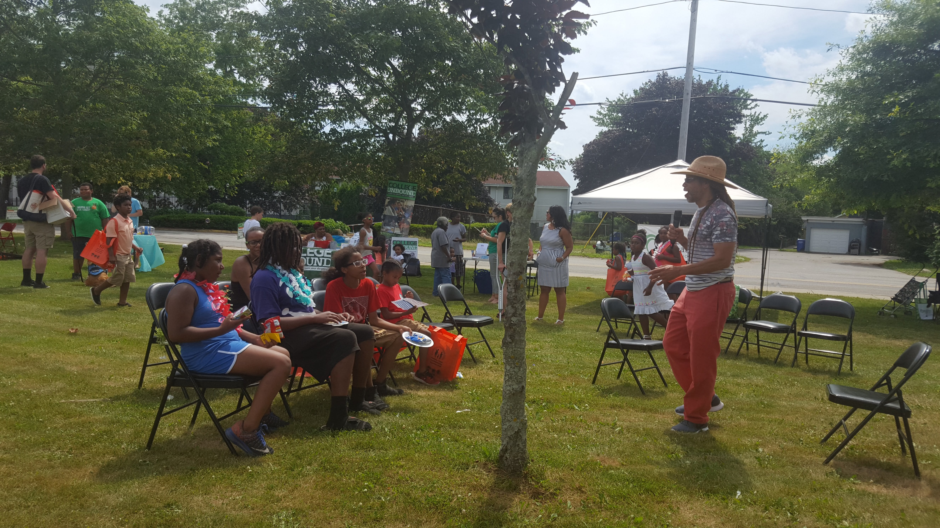
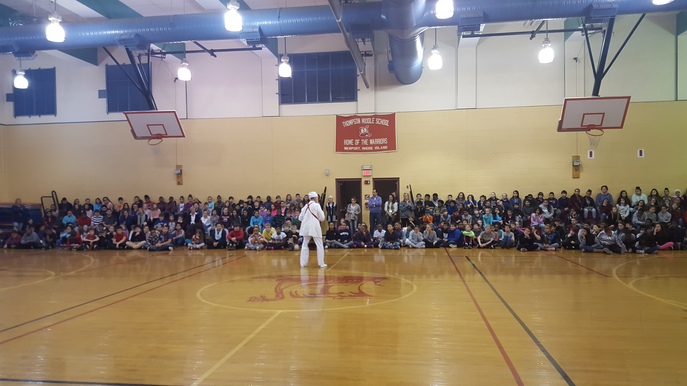
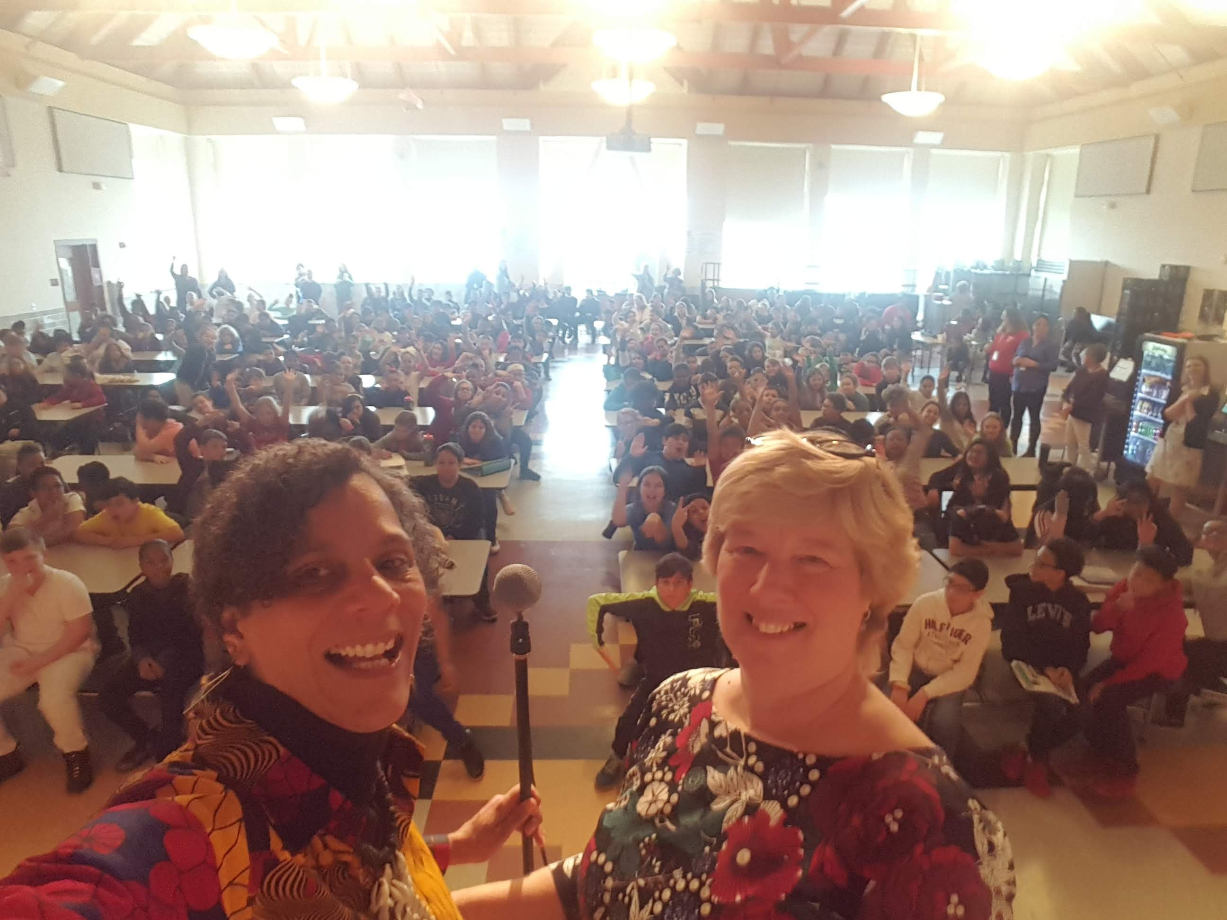
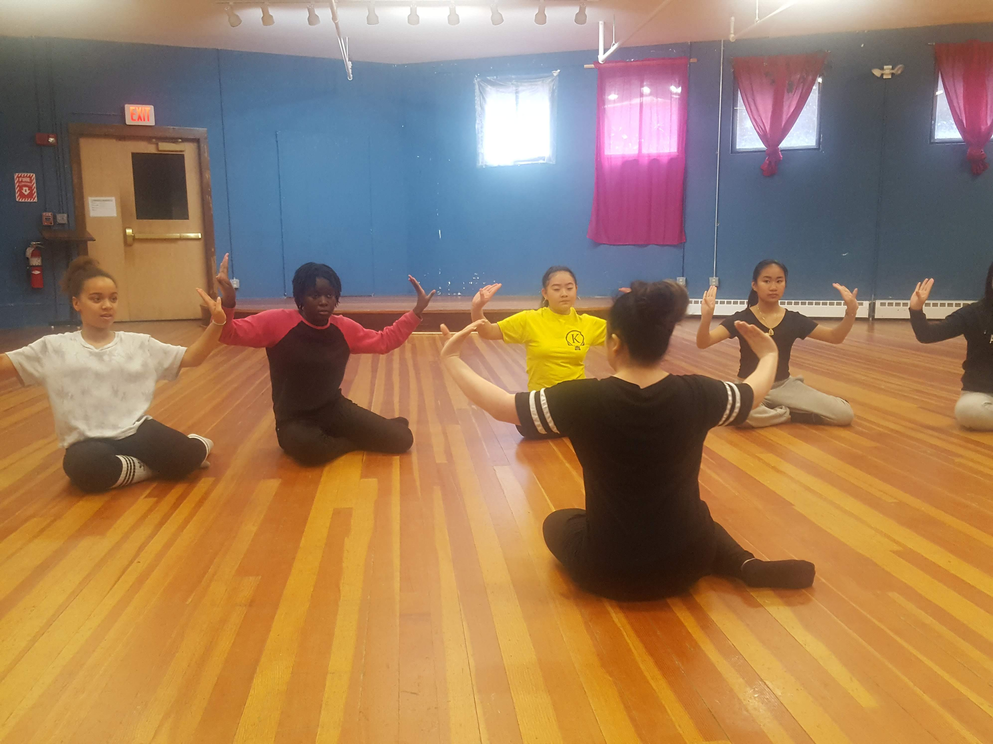
Our History and Mission

RIBS Update

Rhode Island Black Storytellers (RIBS) is a non-profit organization dedicated to promoting the awareness, appreciation, and application of Black Storytelling in Rhode Island through performance, as well as through educational and cultural experiences. Our flagship event is the Annual FUNDA FEST: A Celebration of Black Storytelling which takes place each January all across Rhode Island, reaching over 5000 people in schools and public venues. Additionally, RIBS offers workshops in storytelling, writing, and related arts as a part of the development of the next generation of storytellers along with professional development workshops for those interested in enhancing cultural awareness, and improving their performances and communication skills.  Our Programs are Growing!  Funda Fest: A Celebration of Black Storytelling; 22 years young! |  | RIBS and GEMS: storytelling at FUNDA and Langston Hughes Community Poetry Reading!  FUNDA ARTIST Ron Daise at Gilbert Stuart Middle School: Workshop on Gullah Culture

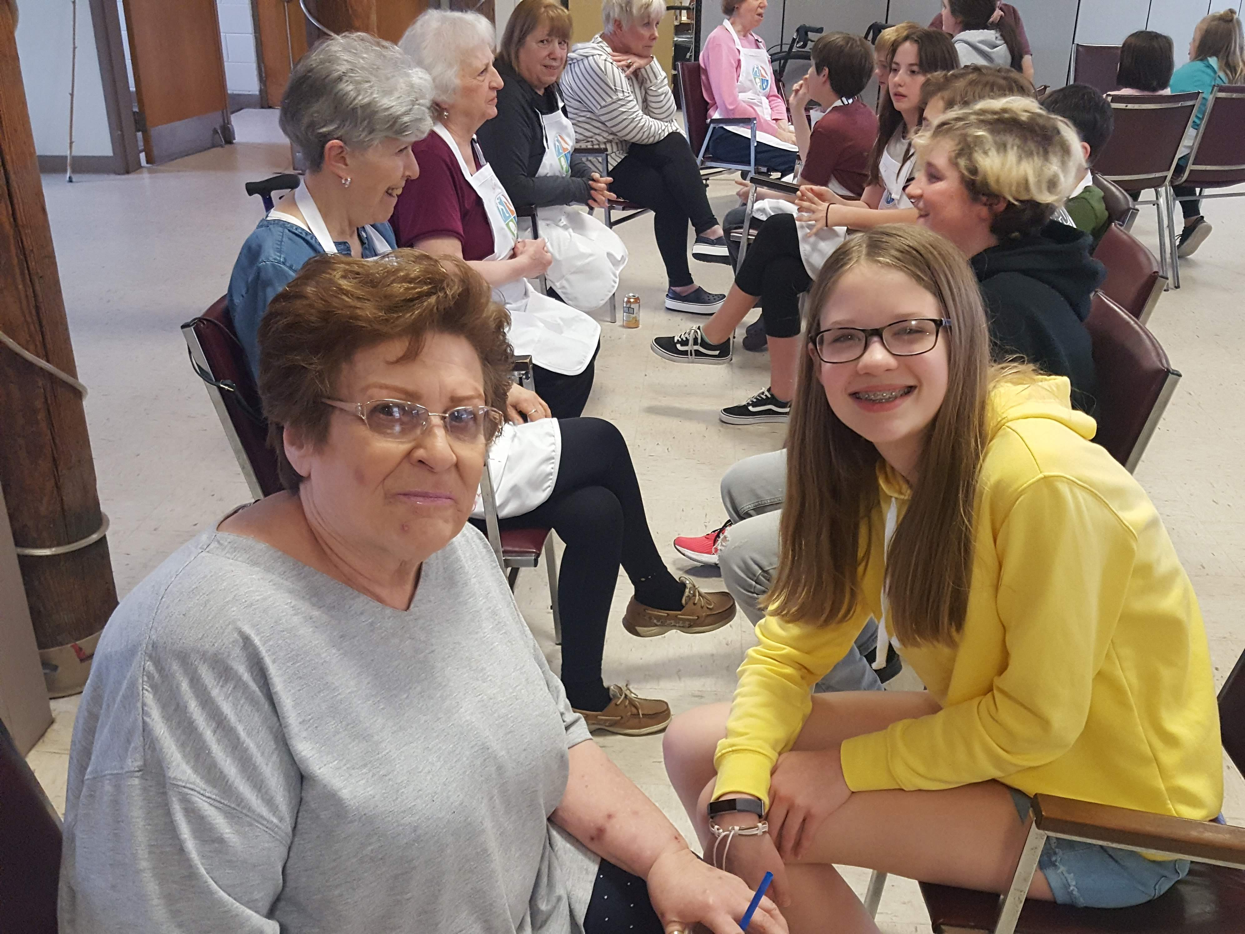 |  | Intergenerational Farmers Market Storytelling Project  For the past 2 years RIBS has partnered with LISC (Local Initiatives Support Corporation) to develop and present intergenerational storytelling workshops with senior adults and youth. This project, funded by TUFTS, helps address the challenges of senior isolation, and create intergenerational experiences and bonds. RIBS has worked in Providence, Newport, Central Falls and Bristol. We have also partnered with the Rhode Island Latino Arts in Central Falls and Providence for a bilingual experience as well!
Dance and Story Bridge Project  RIBS and the Laotian Community Center teamed up this spring with an Intercultural Seed Grant from the Expansion Arts Program. Girls with Black and Asian heritages had the opportunity to get to know each other and one another’s cultures AND dance and storytelling skills. They learned and performed a traditional Laotian dance and a Haitian folktale |  | 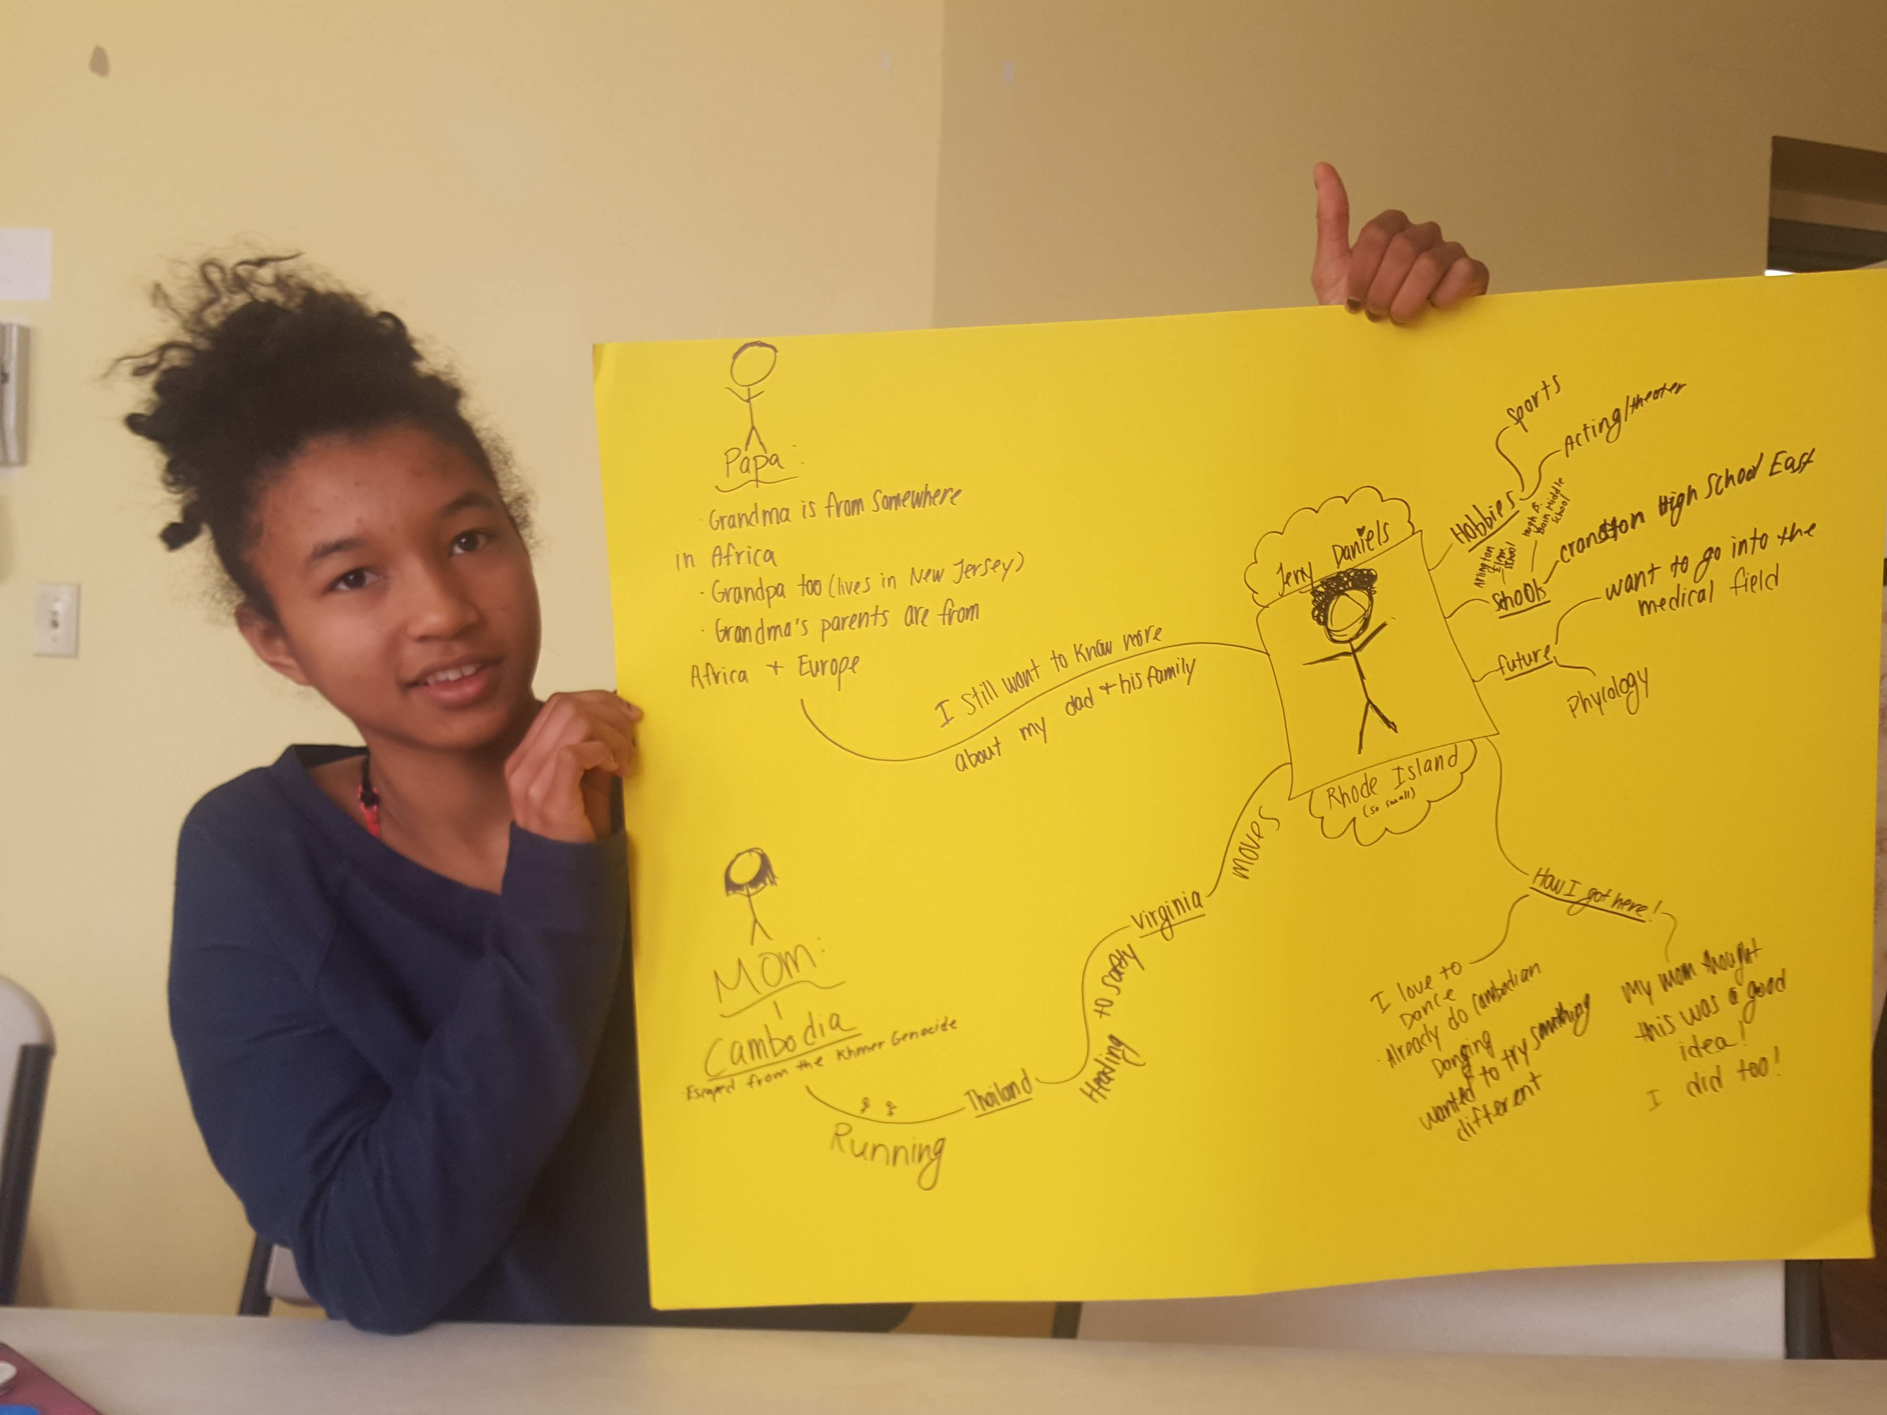
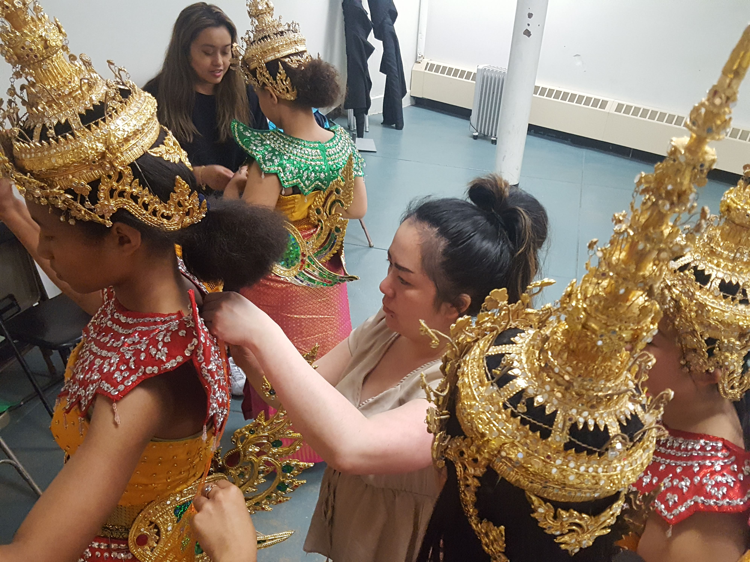 |  | RIBS Partnerships Are Expanding; Stories in Demand  RIBS has been developing programs and partnerships  LISC, The Sowing Place Initiative, GEMS and the YWCA, the Langston Hughes Community Poetry Reading, Rhode Island Latino Arts, The Laotian Community Center, Gilbert Stuart Middle School, and more!  We need your help to bring our stories and our storytellers for the next generations!

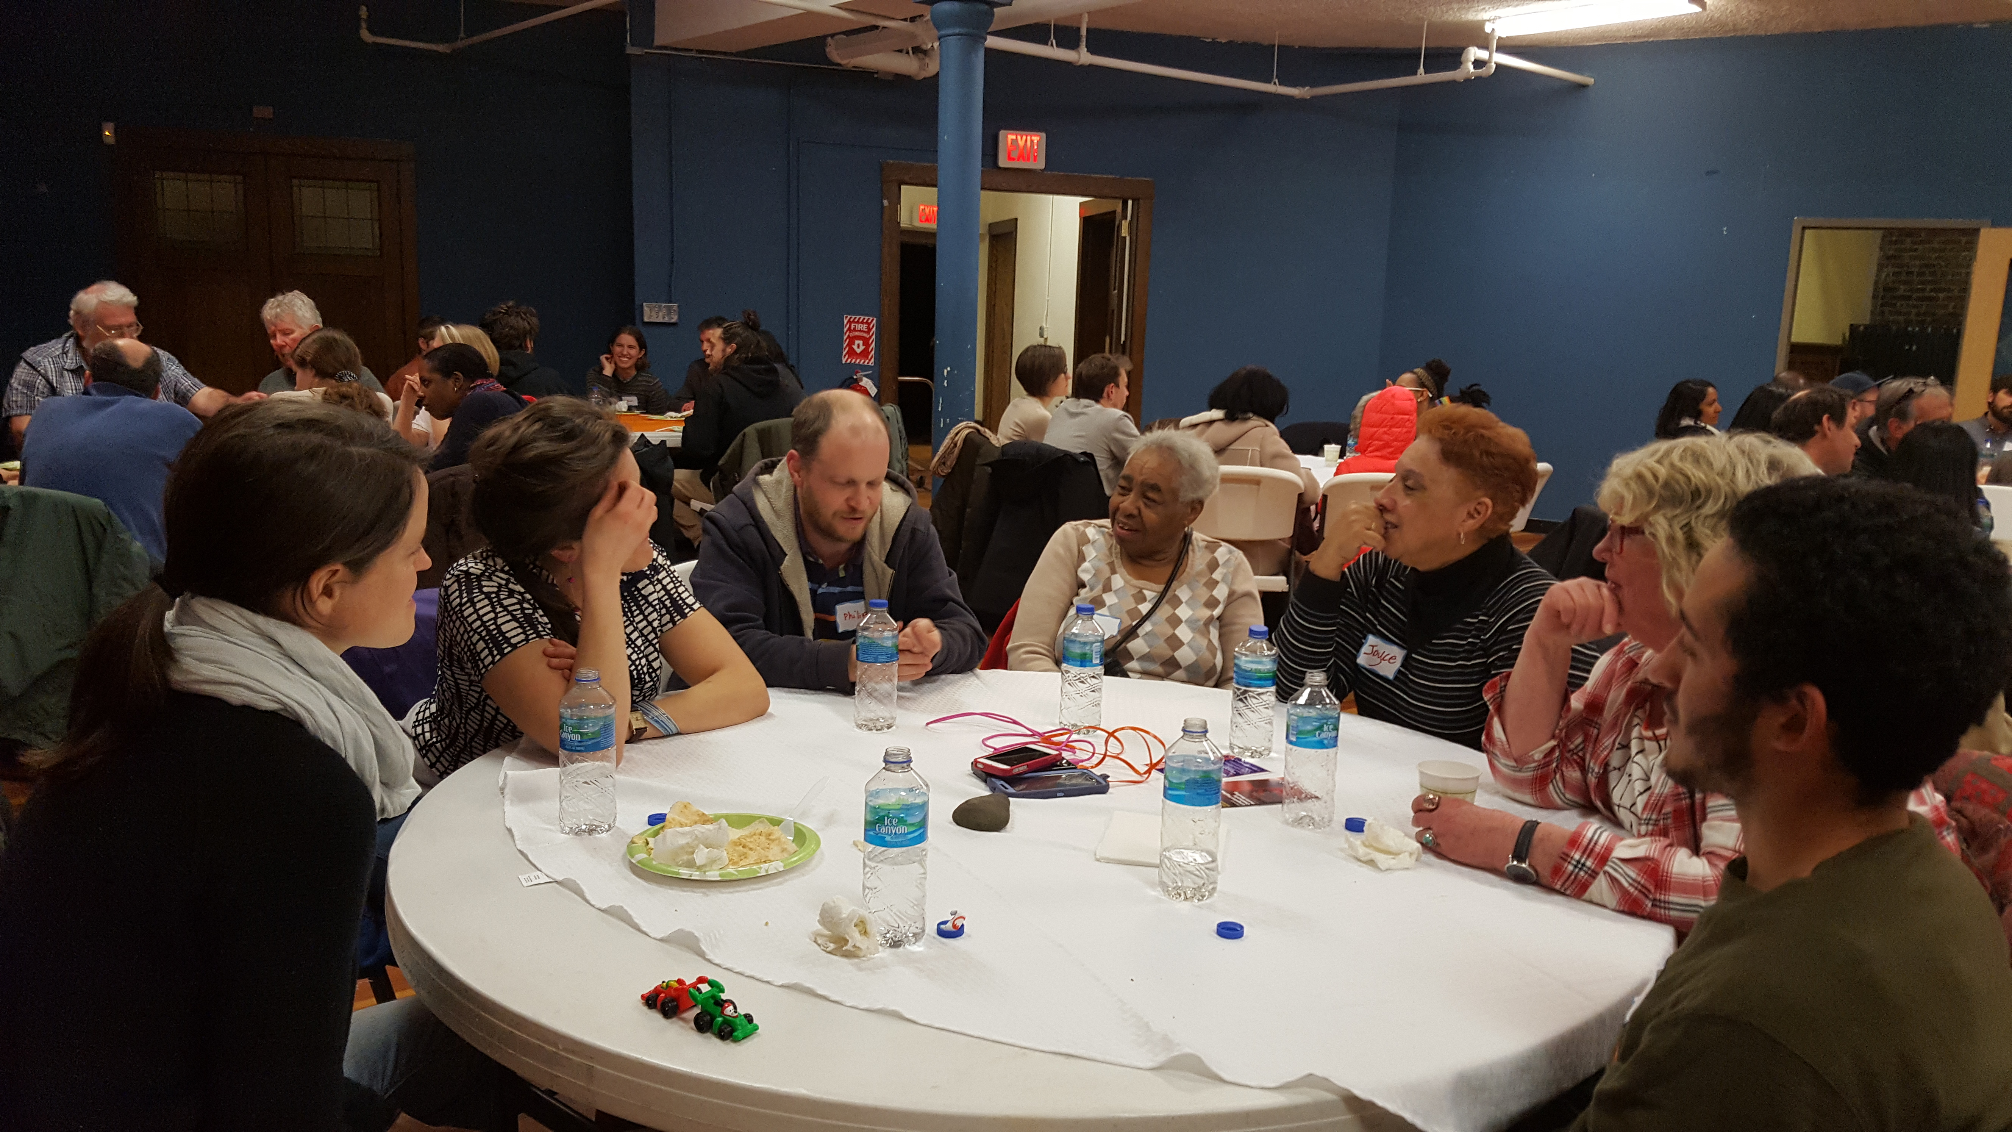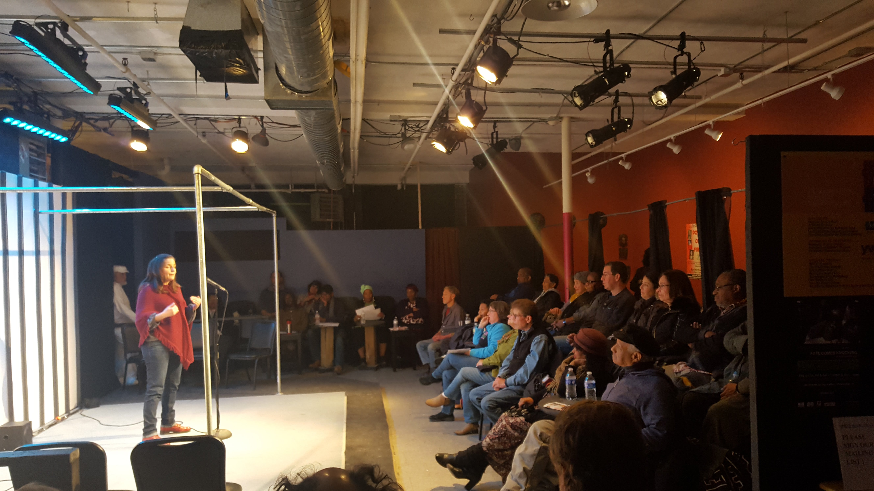

Community Flavors:

A gathering of and for all to share food and stories.
FUNDA FEST Liars’ Contest: Mixed Magic Theatre
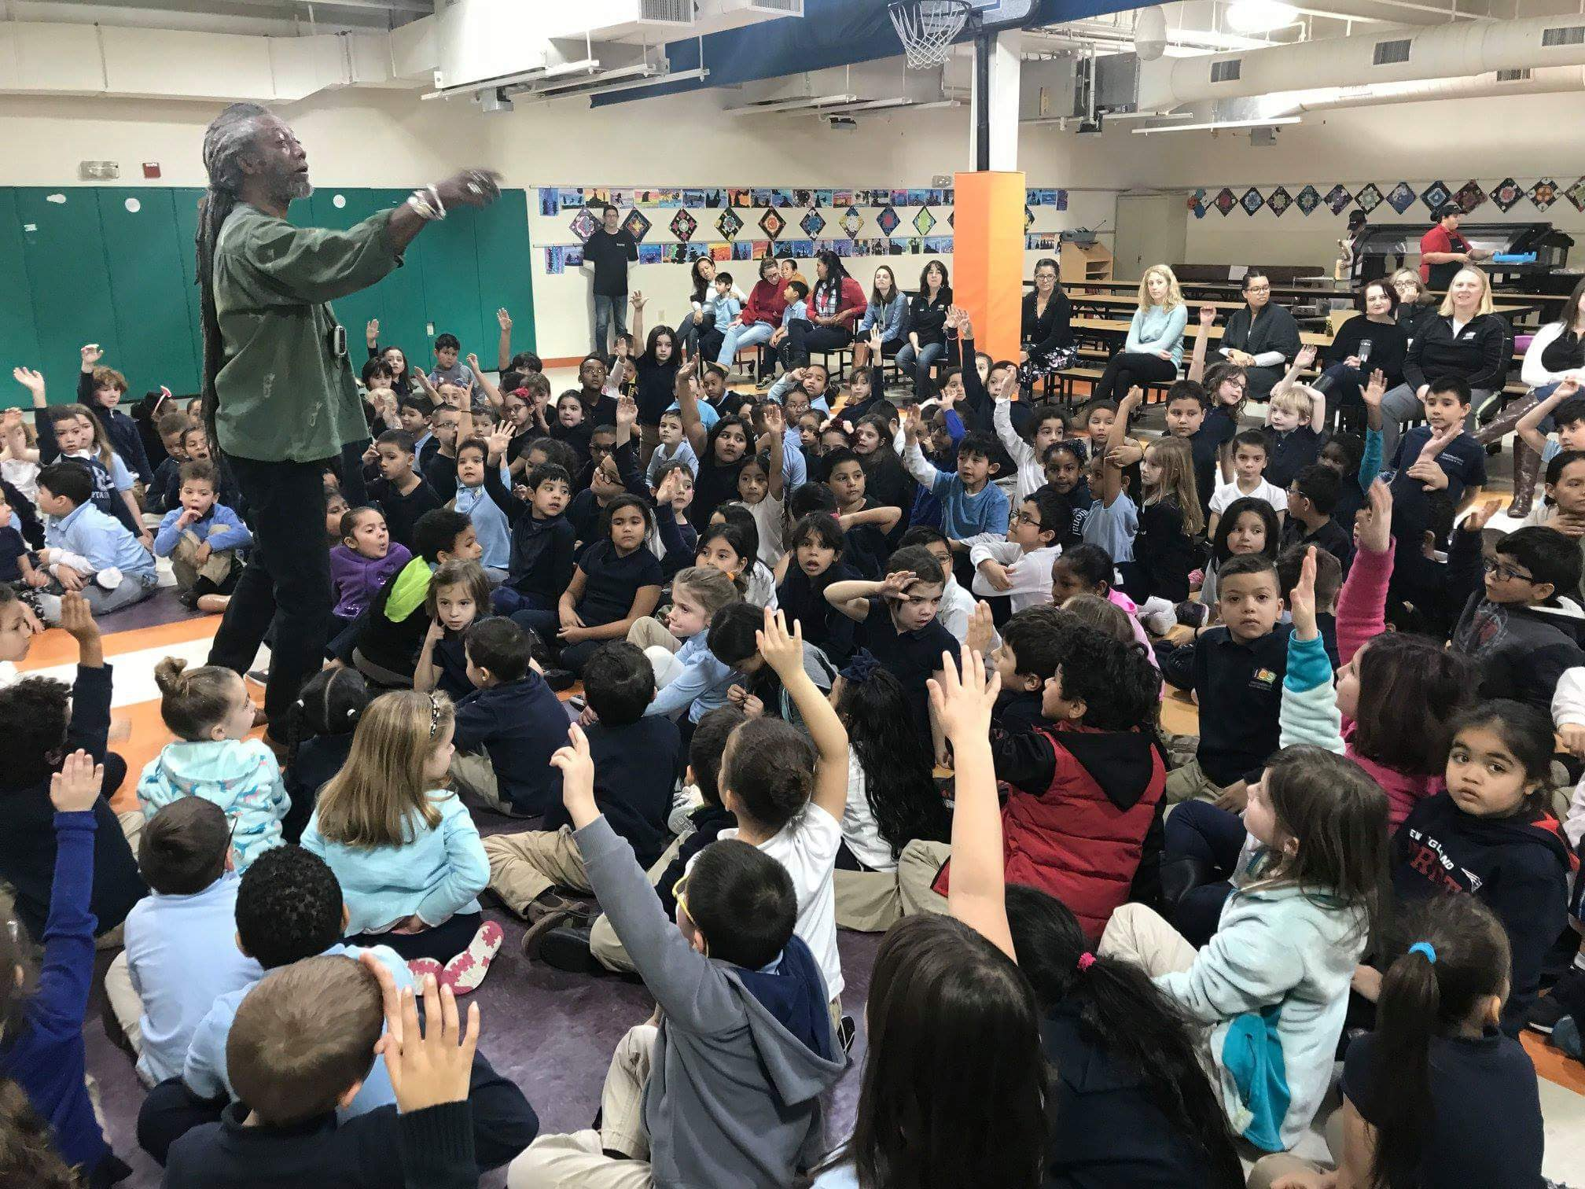
STORYTELLER Len Cabral in the Schools for FUNDA FEST
FU

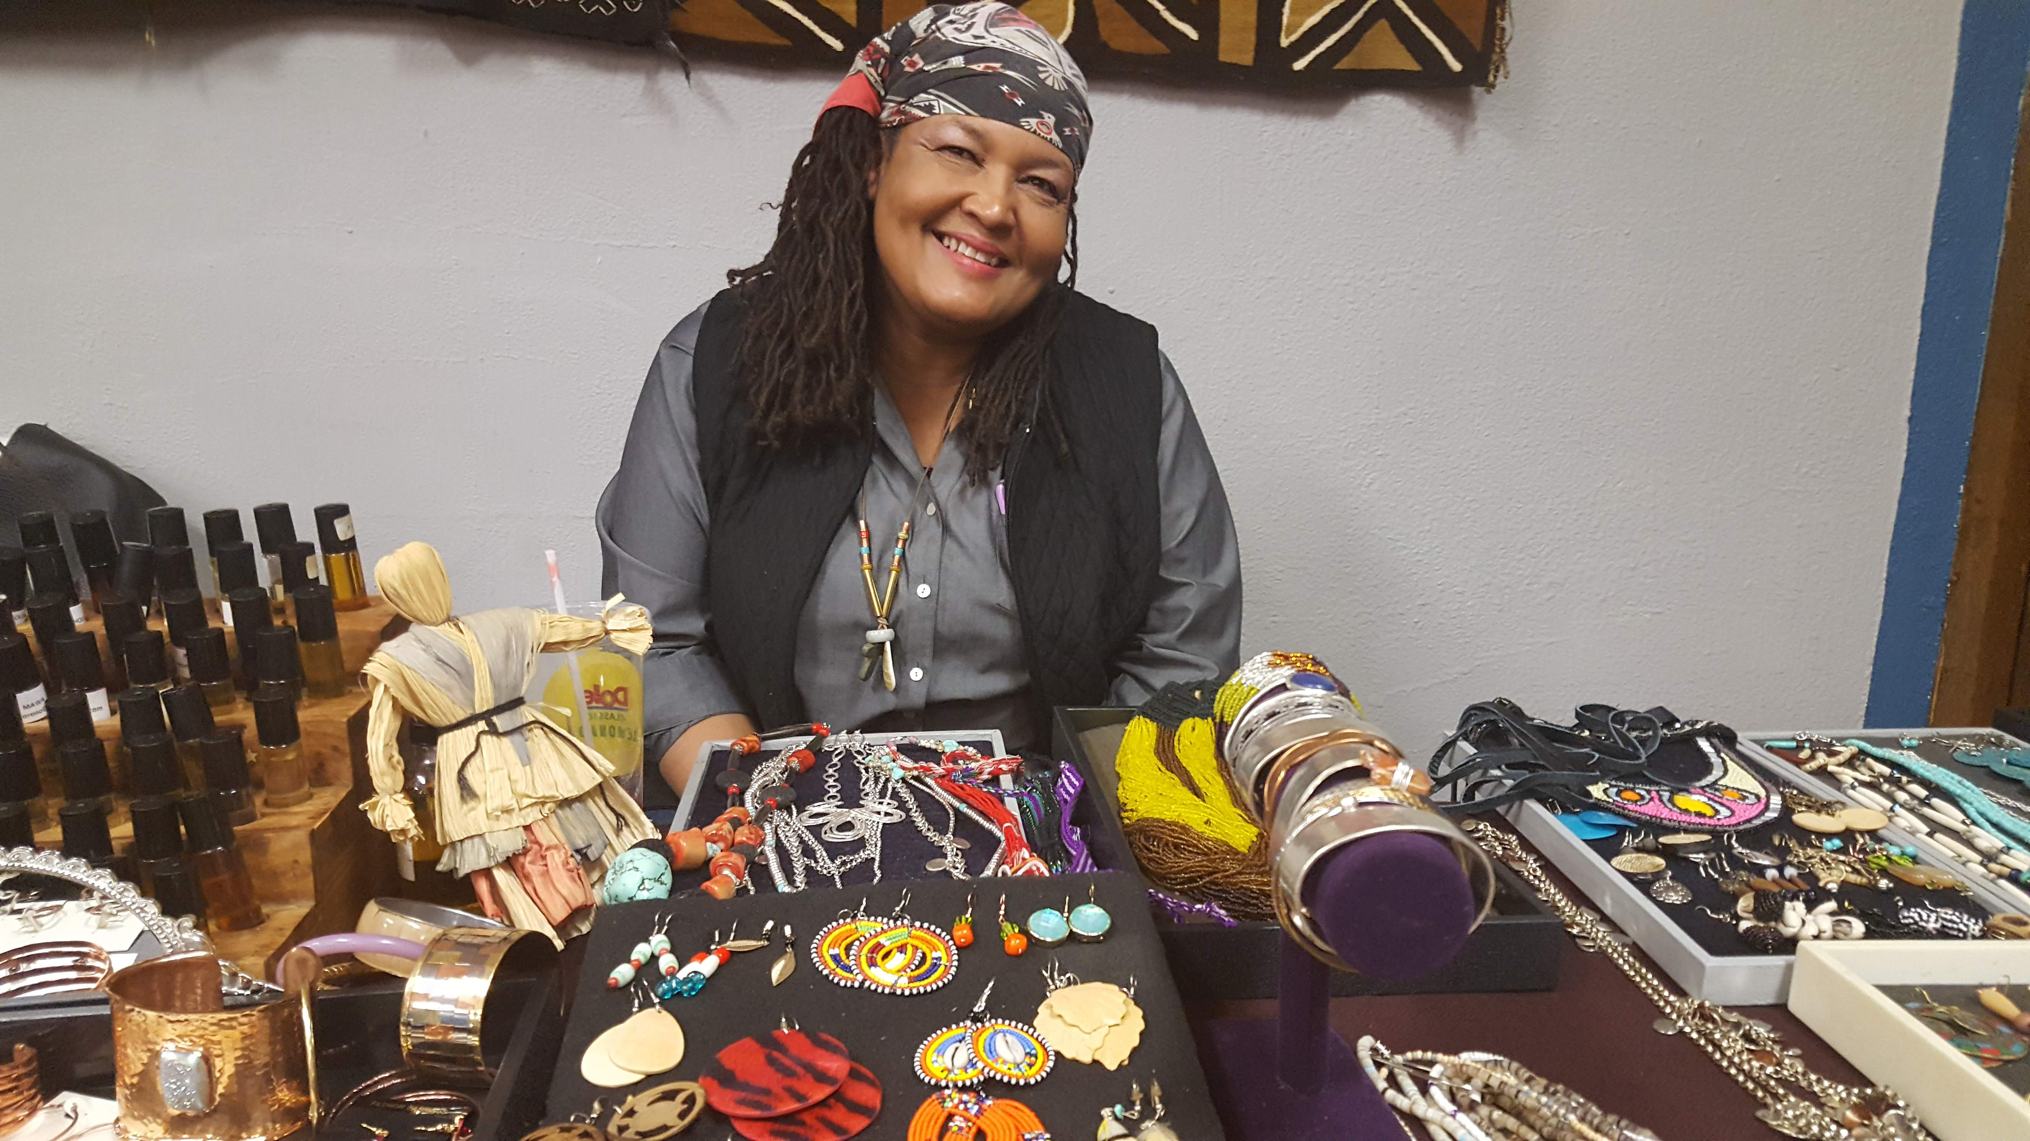
Cultural Extravaganza and Holiday Market at the Southside Cultural Center of RI, in partnership with the Sowing Place Initiative, December 2018

Juneteenth Joy Jam: A Liberation Celebration at the Southside Cultural Center of RI, June 2019
