Thoughts on Women’s History Month
Celebrating Women’s History Month flows seamlessly from Black History Month. Many of the historical figures highlighted during Black History Month are women, so storytellers can often tell the same stories to new audiences or tell the ones prepared but not shared. This can be a blessing given the frenetic pace of engagements during February. This leads to the perennial debate about a month to celebrate Women’s History or Black History, when the depth of historical contributions of women or Black people are only lightly touched, even in the flurry of activity, in a month, and then overlooked for the rest of the year. Fortunately, for those who are serious about the experience and contributions of Black people, this narrow focus is not the case. In fact, a growing number of storytellers greet audiences in February with, “Happy Second Black History Month of the year” and go on to express to audiences that Black History happens and should be celebrated every month of the year. So, welcome to the 3rd Women’s History Month of the year to you!
Beyond the issue of the impact of a monthly celebration is the question of who we celebrate. Certainly, as Blackstorytellers, we celebrate Black women and their continual contributions. We sometimes, though, focus on a few familiar names; and certainly, women like Phillis Wheatley, Harriet Tubman, Rosa Parks, and other well-known women deserve their fame because of the work that they did.
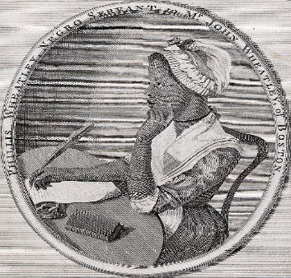
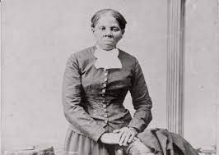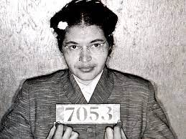
Phillis Wheatley Harriet Tubman Rosa Parks
We need to continue to celebrate these brave and courageous women, but also celebrate those lesser known, often ignored “hidden figures.”
We have the advantage of being storytellers, which means bringing history to life. We can tell of real living people, not just symbolic characters. When we make our history live, we connect it to the lives of people in our audience, making for a more memorable experience. And, we might learn something as we enjoy telling the tale.
So, what do we do differently this year for Women’s History Month? Many of us are old enough to have participated in aspects of the civil right movement. As a teenager, I did my share of sit-ins and singing, “We shall overcome.” In fact, when my daughter did a report on the civil rights movement, we talked and she said with astonishment,” Mom you are a part of history.” Many of us are, so we can tell our own stories and our family stories; and not just stories associated with national events, but the triumph of conquering everyday life. As poet Lucille Clifton said, “Ordinary is extraordinary,” and Zora Neale Hurston told us that “women are the mules of the world.”
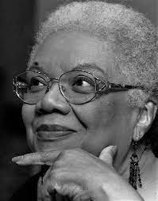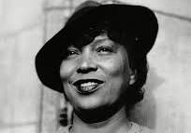
Lucille Clifton Zora Neale Hurston

We did the work that allowed the famous ones to make speeches, organize marches, or stage rebellions. So, tell those “Behind the scenes” stories that support the famous ones that we have heard or told every year. Also, tell your own stories of the women in your life who made history just by living each day.
And one more thing, Women’s History Month has a history of being in the shadows of Black History Month for Black people, for several reasons. Historically, Black women have struggled with being both Black and woman. Frankly, the woman side has often been considered secondary to being Black, and when included it has been Black and woman, fitting neatly into Black History Month, but not Women’s History Month. Relatedly, Black women have sometimes associated Women’s History Month with the feminist movement that some rejected as being for White women. Then Black womanists such as Audre Lorde and bell hooks made the case for Black women. More importantly, Black women made the case for Black women through their actions and their lives.
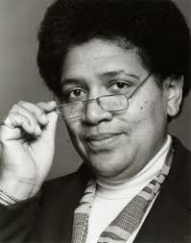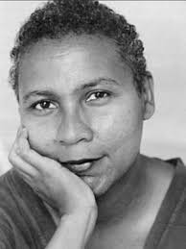
Audre Lorde bell hooks

However we see it, it’s the charge to Blackstorytellers to tell the story of Black lives every month-- for ourselves, for our youth, and for generations to come. Pass it on! By the way, if you research and look more deeply into lives of just the women pictured here, you will have a wealth of women’s history stories to tell.
Dr. Carolyn Edwards

