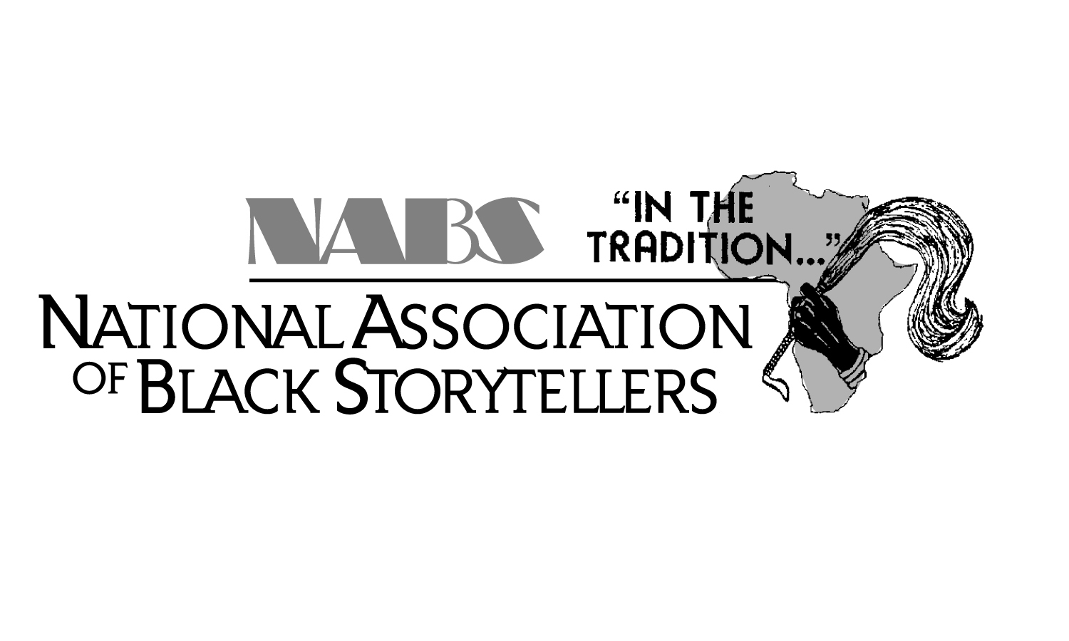 | NATIONAL ASSOCIATION OF BLACK STORYTELLERS, INC.  P. O. BOX 67722 · Baltimore, Maryland 21215 · (410) 947-1117 www.NABSinc.org
FOR IMMEDIATE RELEASE
August 1, 2023
Contacts
Festival Director NSOUL-Nubian Storytellers Of Utah Leadership
Dylan Pritchett Charlotte Starks
(757) 561-6658 (801)300-5895
aesop@widomaker.com Charstarks@comcast.net

THE NATIONAL ASSOCIATION OF BLACK STORYTELLERS, INC.

presents
41st Annual National Black Storytelling Festival and Conference
“In the Tradition…”
Telling Our Stories From The Mountaintops!

The National Association of Black Storytellers, Inc. (NABS) will present the “In the Tradition…” 41st Annual National Black Storytelling Festival and Conference! This year, NABS will be conducting their unique gathering Salt Lake City, Utah at the Sheraton Salt Lake City Hotel, November 8-12, 2023.

The first "In the Tradition..." Festival of Black Storytelling was held at Morgan State University in Baltimore in 1983. Since then, they’ve traveled throughout the country and approaching 41 years of celebrations. In honor of our Ancestors and in encouraging preservation of our traditions, this year’s theme is “Telling Our Stories From The Mountaintops!”

In 1982, nationally renowned storytellers, Baltimore’s first officially appointed Griot – the late, great Mary Carter Smith of Baltimore, Maryland, and esteemed Linda Goss of Philadelphia, Pennsylvania (now residing in Baltimore)– founded “In the Tradition…” National Black Storytelling Festival. These visionaries then created the National Association of Black Storytellers, Inc., so that more opportunities would be afforded African American storytellers to perpetuate the African oral tradition and preserve the folklore of African people.

Master Storytellers, as well as, beginners, storytellers with instruments and storytellers who dance, storytellers of all styles will entertain, inspire, educate and enliven the myths, recite the poems and recount the history of a people. Featured Tellers this year are: Masankho Banda (Malawi), Diane Ferlatte (CA), Lynette Ford (OH), Kunama Mtendaji (MO), Valerie Tutson (RI), Roshanda Womack (MI) & Donna Willingham (OH). Our Saturday Youth Concert will highlight Salt Lake City’s finest youth groups. Also, additional stories will be performed by Appalachian Black Storyteller Fellows, Village Tellin’ stories shared by members of our fourteen affiliates, story swaps and opportunities for attendees to share their talents during the always popular Jackie Torrence Tall Tales Contest! Added to all of this are workshops for the novice and professional tellers lead by Mary Grant, Willa Brigham, Masankho Banda, Lynette Ford, Valerie Tutson, Sharon Holley and Karima Amin. A special bonus will be morning sessions on relevant discussion on the health and well being facing of Black Storytellers!

The National Association of Black Storytellers, Inc. is proud to present this one-of-a-kind event for the community, country and the world! This is what to expect:

ADOPT-A-TELLER: Storytellers available to perform a 45-minute live performance at local schools, libraries and other venues throughout the Baltimore area. There is an application fee but the performance is FREE! Limited availability. Contact Queen/Bunjo at aatp@nabsinc.org for additional information and availability.

OPENING GALA, STORYTELLING CONCERT & MARY CARTER SMITH LOVE CIRCLE: Traditional opening with stories, pomp and circumstance!

VILLAGE TELLIN’: Our fourteen Affiliates from across the country will share their unique regional and cultural flare as they weave their stories. A crowd pleaser!!

“IN THE TRADITION…” CONCERT featuring the Appalachian Fellowship Storytellers and YOUTH CONCERT to watch Salt Lake City’s finest youth performers make us proud!

ADULT JACKIE TORRENCE TALL TALES CONTEST: Festival Favorite!!!!! Members and non-members can compete…sharing their fantastic fabrications and lies…uh..tall tales!!.

ZORA NEALE HURSTON AWARD AND STORYTELLING CONCERT: An evening storytelling concert and awards recognizing excellence in the BlackStorytelling community!

MAMA LINDA GOSS CLOSING UNITY CIRCLE: Our traditional closing ceremony.

Since the first Festival and Conference in Baltimore, NABS has traveled around the nation; most recently, New Orleans, LA ('04), Tampa, FL ('05), San Diego, CA ('06), Atlanta, GA (’07), Cincinnati, OH (’08), Little Rock, AR (’09), Minneapolis, MN (’10), Atlanta, GA (’11), Baltimore, MD (’12), Hampton, VA (’13), Chicago, IL (‘14), Washington, D.C. (’15), Philadelphia (’16), Wichita, KS (’17), Cary, NC, (’18), Montgomery, AL (’19), two virtual festivals (‘20/’21), 40th anniversary in Baltimore, Maryland(’22) and now SALT LAKE CITY, UTAH!!
COME JOIN US!!
“TELLING OUR STORIES FROM THE MOUNTAINTOPS!”

FOR PROGRAM SCHEDULE & REGISTRATION INFORMATION VISIT

WWW.NABSINC.ORG

OR CONTACT

Dylan Pritchett at (757) 561-6658, aesop@widomaker.com

