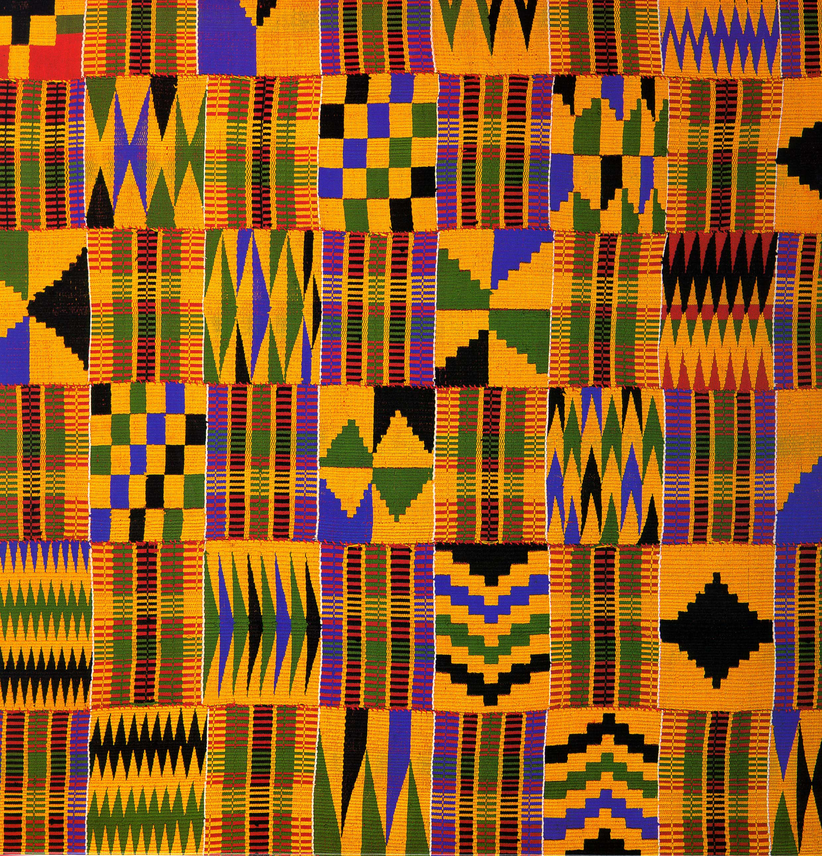

DABS 2023 ASSOCIATION YEAR REPORT

Here is the DABS 2023 Report

DABS has continued the successful 4th Friday Storytelling events which features DABS tellers.

We also have a Youtube Channel (Detroit Association of Black Storytellers).

Elder Johnny Bellamy has been ill but is currently recovering. Prayers to him and his lovely wife as they meet this challenge with their usual grace and faith.

We had a very successful Black History Month Concert at the Charles Wright Museum in February. The theme was Black Resistance with very powerful stories told by Janice Burnett, Pam Olden and Elder Vicki Slaughter.

We had a very successful in person Fall concert in September (September 9th) which included stories from Elder Mary Grant, Maxine Hankins Cain, Roshonda Womack, Elder Gwendolyn Lewis and one of our Spoken Word members “Prophet”.

DABS will film Holiday Stores at the Detroit Public Library which will be featured on the DPL website.

Our Spoken Word Team (youth outreach) was active in 2023 and were featured in a special 4th Friday event. They are also planning 2 events in 2024.

We are planning a Founders event in June of 2024.
Podcast.

Look out for our new video promo to promote storytelling opportunities for our members.

