The Griots’ Circle of Maryland, Inc.
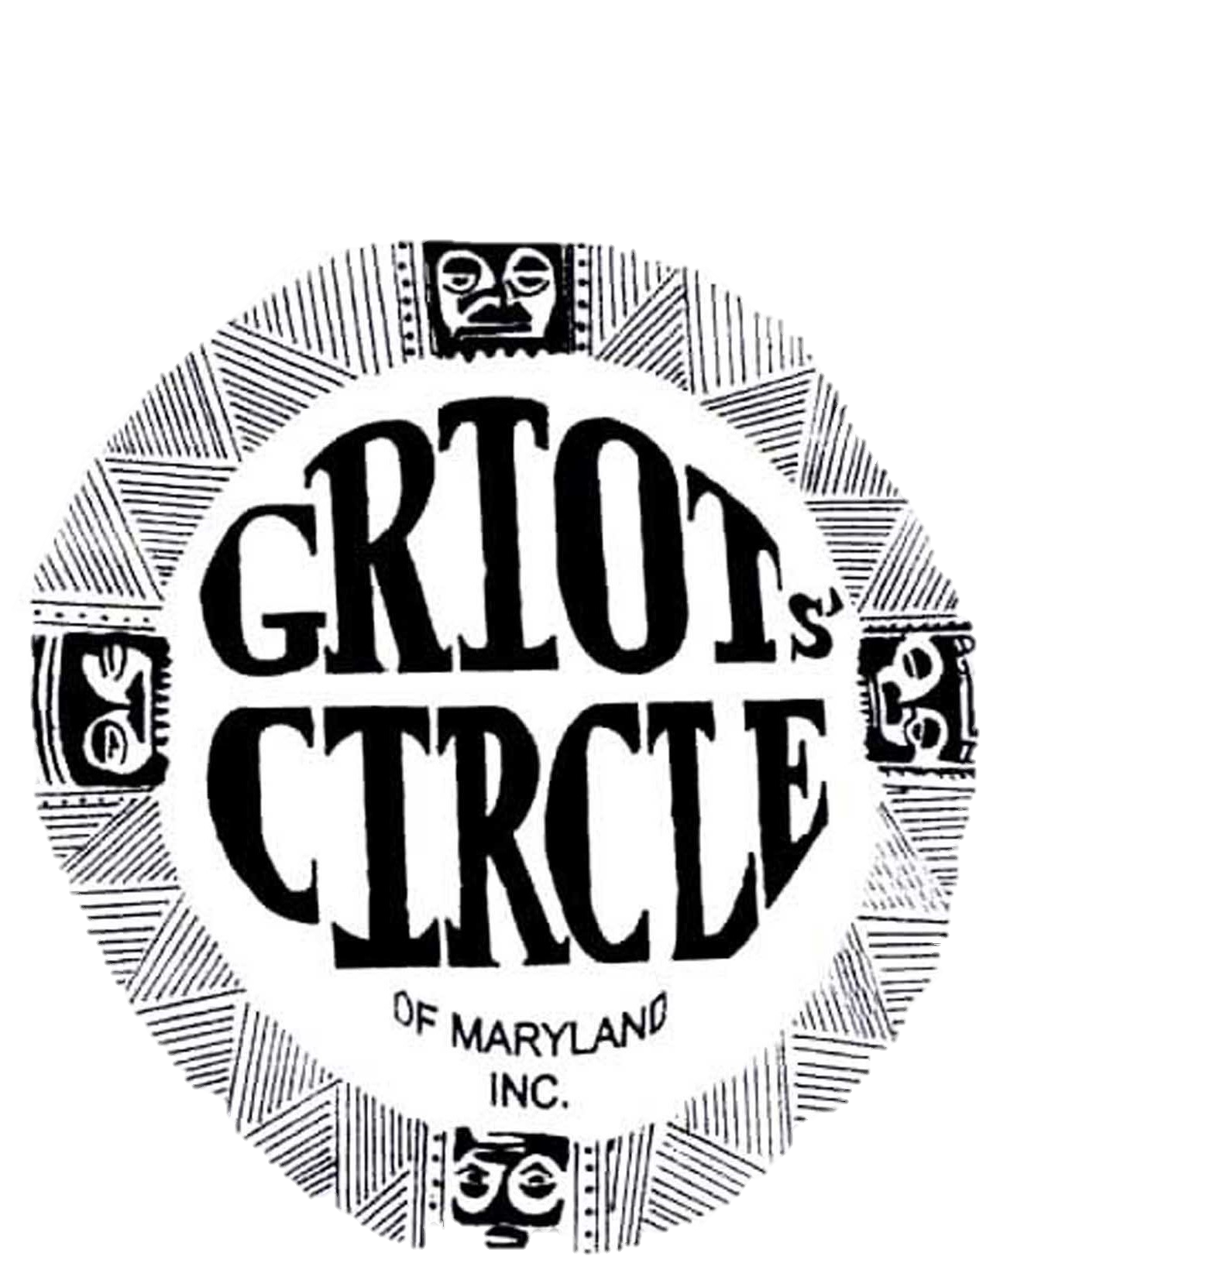
Annual Report
November 2021 - October 2022

This year we carried out plans to co-host the 40th NABS "In the Tradition . . ." National Black Storytelling Festival and Conference. We held a successful fundraising campaign and a well attended community storytelling fundraising program. Several community supporters donated to our campaign. Our public relations team secured promotional spots on a radio station that streams world wide. The community event was covered by the local newspaper and television. For the festival, we arranged the heritage tour and the pre-festival program.
As the threat of the covid 19 virus diminished, we also took steps to begin in person and hybrid meetings and performances. Our monthly business meetings were held virtually by zoom until September. Then we began hybrid meetings. Our monthly gatherings included storytelling trainings, historical talks or performances. These sessions included networking with other NABS members, the Growing Griots, our youth component and community members.
After over a year of editorial work, The Griots' StoryBook was published with writings from Griots' Circle members. This project appealed to many new members who live in other states. The book will be sold at events and online.
The Griots' Circle website was regularly updated with new events. "Find A Teller" was a new feature added to the website. Members agreed to pay a fee to be on the webpage which gives the public contact information for hiring a storyteller.
After 2 years of not gathering, the Griots' Circle was able to get together and take a group photograph. In October, they also celebrated Edna Ruff, their oldest member who had a 100th birthday.
Our membership has increased and a few members have taken out life membership. We look forward to continuing the vibrant organization which was founded by Mother Mary Carter Smith.
Submitted By
Karen Burdnell, President

November 6 – 13, 2021
Participation in the NABS 39th Festival and Conference:
- Presenters: Bunjo Butler, Renee Emanuel, Dr. Caroliese Frink-Reed, Gail Harrison,
Dr. David Fakunle
- Awards:
Vanora Legaux, Zora Neale Hurston Award
Paris Greene & Candece Tarpley, Brother Blue Circle of Elders Award
Eslyn Hinmon, Linda Jenkins Brown Nia Award for Service
Alexander Reid, Naomi Reid & Xavier Reid, Baba Jamal Koram Youth Award

December 4, 2021
- Award: Gordon "Soorah" Parks, Mary Carter Smith Legacy Award
- Kwanzaa Program presentation

January 8, 2022 - Spiritual and Inspirational Stories

February 5, 2022 - Fanny Crawford’s Activist Parents

March 5, 2022 - Spotlight on Growing Griots

April 2, 2022 - Salute to Paul Lawrence Dunbar for 150th birthday

May 7, 2022 - Tips for Presenting Historical Biographies

June 4, 2022 - Round Table Conversation - Remembering GC Ancestors

July 16, 2022 – Growing Griots present at the Annual Voices of History Street Fair

July 31, 2022 - Community Storytelling Fundraiser Program at the Sankofa Children’s Museum

August 6, 2022 - Remembering Family Reunions: Planning Tips and Memories

September 3rd, 2022 - Sites to See: Regional African American history, Hagerstown

October 1, 2022 - Storytelling by LAMBS (Louisiana Mississippi Black Storytellers)

October 9, 2022
- Love Stories Program; Theme: The World's in Need of Love
Awards:
- Janice Curtis Greene named Maryland's Official Griot by Maryland’s Governor
- Grandmother Edna Williams received a Mayoral Salute from Baltimore's Mayor

