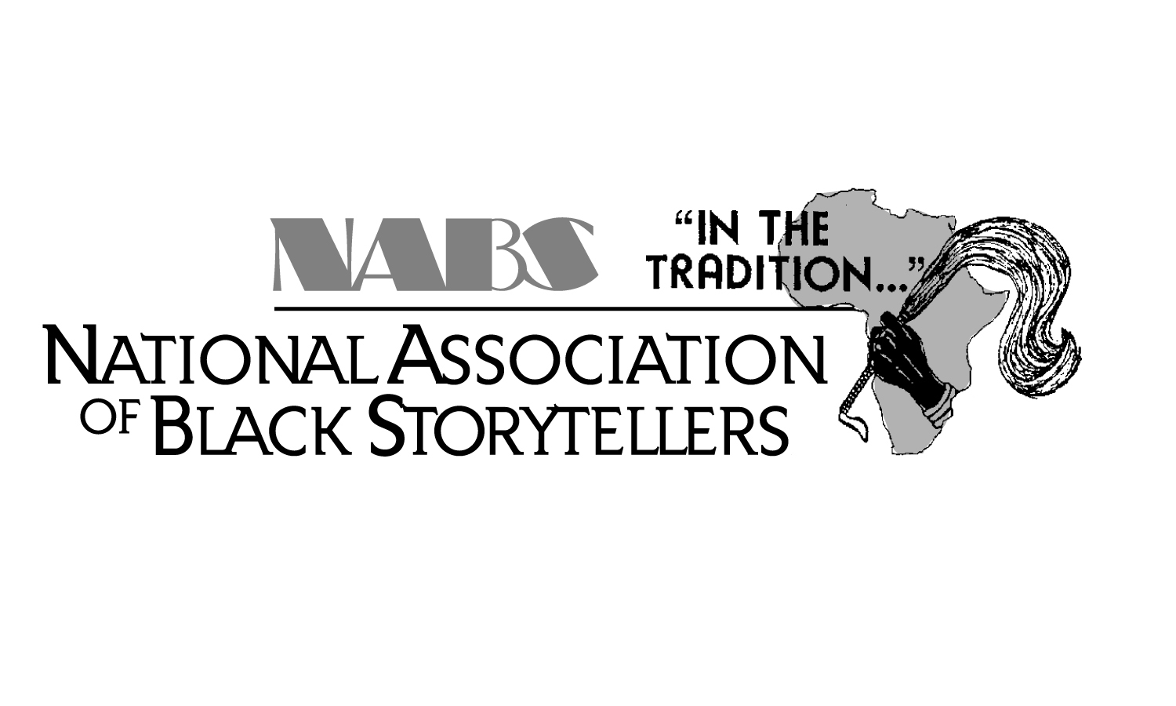 | NATIONAL ASSOCIATION OF BLACK STORYTELLERS, INC.  P. O. BOX 67722 · Baltimore, Maryland 21215 · (410) 947-1117 www.NABSinc.org
FOR IMMEDIATE RELEASE
September 11, 2022
Contacts
Festival Director Dylan Pritchett Co-Host/Griots’ Circle of Maryland
757-561-6658 Janice Curtis Greene (443) 253-1804
aesop@widomaker.com janicethegriot@aol.com

THE NATIONAL ASSOCIATION OF BLACK STORYTELLERS, INC.

presents
40th Annual National Black Storytelling Festival and Conference
“In the Tradition…”
40 Years STRONG – The Power of BlackStorytelling!

The National Association of Black Storytellers, Inc. (NABS) will present the “In the Tradition…” 40th Annual National Black Storytelling Festival and Conference! This year, NABS will be conducting their unique gathering in Baltimore, Maryland at the Sheraton Inner Harbor Hotel, November 9-13, 2022.

The first "In the Tradition..." Festival of Black Storytelling was held at Morgan State University in Baltimore in 1983. Since then, they’ve traveled throughout the country and approaching 40 years of celebrations. In honor of our Ancestors and in encouraging preservation of our traditions, this year’s theme is…“40 Years STRONG – The Power of of BlackStorytelling!”

In 1982, nationally renowned storytellers, Baltimore’s first officially appointed Griot – the late, great Mary Carter Smith of Baltimore, Maryland, and esteemed Linda Goss of Philadelphia, Pennsylvania (now residing in Baltimore)– founded “In the Tradition…” National Black Storytelling Festival. These visionaries then created the National Association of Black Storytellers, Inc., so that more opportunities would be afforded African American storytellers to perpetuate the African oral tradition and preserve the folklore of African people.

Master Storytellers, as well as, beginners, storytellers with instruments and storytellers who dance, storytellers of all styles will entertain, inspire, educate and enliven the myths, recite the poems and recount the history of a people. Featured Tellers this year are: Sharon Holley (NY), Dr. Linda Humes (NY), “In The Spirit”/Zahra Baker & Emily Lansana (IL), Oba William King (TX), Onam Lansana (IL), Sue Roseberry (TX), Queen Nur (NJ), Dr. Rita Cox (Toronto, Canada) & Mitch Capel ”Gran’daddy Junebug” Capel, (NC). Our Youth Program will highlight our Co-Host’s “Growing Griots” youth group as well as place a spotlight on some of Baltimore’s finest youth performers. Also, additional stories will be performed by: Appalachian Black Storyteller Fellows, Village Tellin’ performed by our fourteen affiliate members, story and song swaps and opportunities for attendees to share their talents! Added to all of this, workshops for the novice and professional tellers lead by Sharon Draper, Willa Brigham, Sue Roseberry, Dr. Caroliese Frink Reed, Emily & Onam Lansana and a music/dance workshops lead be Cheryl Hinton.

The National Association of Black Storytellers, Inc. is proud to present this one-of-a-kind event for the community, country and the world! This is what to expect:

ADOPT-A-TELLER: Storytellers available to perform a 45-minute live performance at local schools, libraries and other venues throughout the Baltimore area. There is an application fee but the performance is FREE! Limited availability. Contact Queen/Bunjo at aatp@nabsinc.org for additional information and availability.

OPENING GALA, STORYTELLING CONCERT & MARY CARTER SMITH LOVE CIRCLE: Traditional opening with stories, pomp and circumstance!

VILLAGE TELLIN’: Our fourteen Affiliates from across the country will share their unique regional and cultural flare as they weave their stories. A crowd pleaser!!

YOUTH CONCERT: Baltimore’s finest youth performers make us proud!

ADULT JACKIE TORRENCE TALL TALES CONTEST: Festival Favorite!!!!! Members and non-members can compete…sharing their fantastic fabrications and lies…uh..tall tales!!.

ZORA NEALE HURSTON AWARD AND STORYTELLING CONCERT: An evening storytelling concert and awards recognizing excellence in the BlackStorytelling community! Also, an unveiling of the wax figure to be included in the Great Blacks in Wax Museum enshrining our Co-Founder, Linda Goss.

MAMA LINDA GOSS CLOSING UNITY CIRCLE: Our traditional closing ceremony.

Since the first Festival and Conference in Baltimore, NABS has traveled around the nation; most recently, New Orleans, LA ('04), Tampa, FL ('05), San Diego, CA ('06), Atlanta, GA (’07), Cincinnati, OH (’08), Little Rock, AR (’09), Minneapolis, MN (’10), Atlanta, GA (’11), Baltimore, MD (’12), Hampton, VA (’13), Chicago, IL (‘14), Washington, D.C. (’15), Philadelphia (’16), Wichita, KS (’17), Cary, NC, (’18), Montgomery, AL (’19), two virtual festivals (‘20/’21) and now our 40th anniversary in Baltimore, Maryland!!

COME JOIN US!!
“40 Years STRONG – The Power of of BlackStorytelling!”

FOR PROGRAM SCHEDULE & REGISTRATION INFORMATION VISIT

WWW.NABSINC.ORG

OR CONTACT

Dylan Pritchett at (757) 561-6658, aesop@widomaker.com

