**RIBSSS**

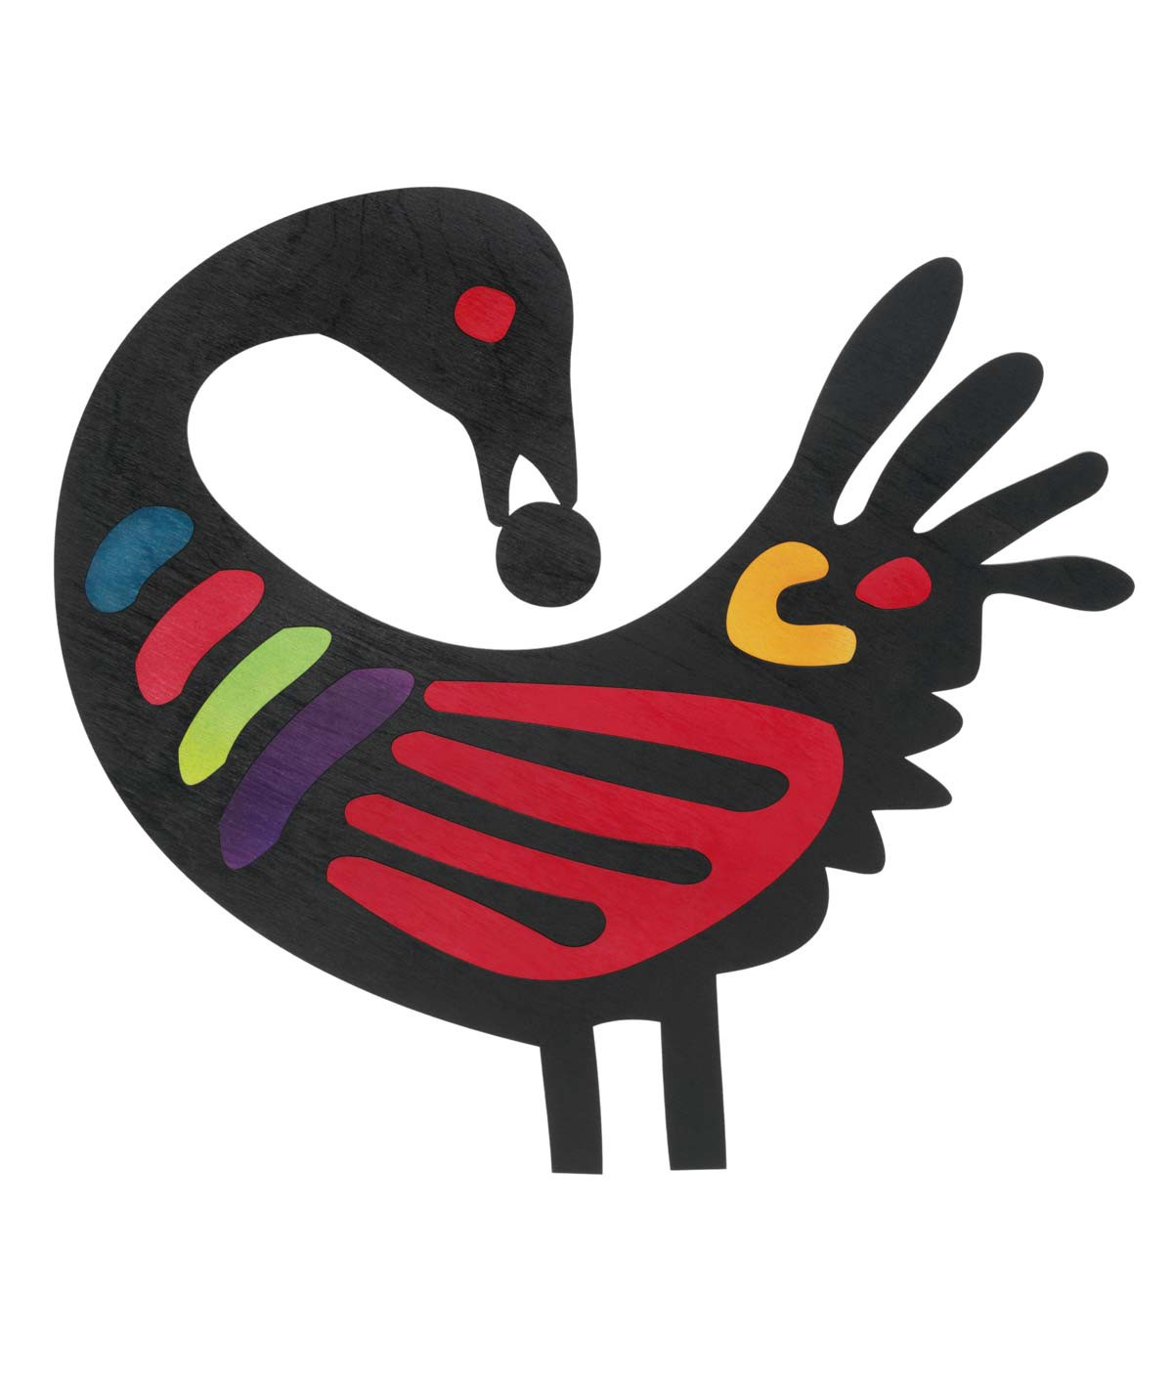



**AFHC**

**CABS**

**BSSD**

**NCABS**

**DABS**

**KOTC**

**BLR**

**ASES**

**BSAS**

**TRADITION KEEPERSGRIOTSCIRCLE**

**GRIOTSCIRCLE**

**NSOUL**

**KUUMBA**

“Well, oh well, oh well. It’s Storytelling time!”

**Virtual Village Telling**

Sponsored By

**National Association of Black Storytellers**

July 14, 2021 & August 11, 2021

8:00 PM (EDT) - 9:30 PM (EDT)

Storytellers from all 14 NABS Affiliates

Telling Stories about their Villages

**Free and Open to the Public**

Registration Required

