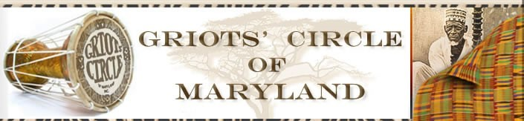

GRIOTS’ CIRCLE OF MARYLAND
ANNUAL REPORT FOR 2017

Griots’ Circle Goals for 2017-2018
- To facilitate Griots’ Circle meetings in a professional and timely manner.
- To increase programming beyond Baltimore City
- To increase visibility in the media
- To develop and implement workshops to enhance our members storytelling skills
Election of new officers in January 2017 - 2018
President – Kay L. Merrill
Vice President - Akua Anansesemfo
Secretary - Karen Burdnell
Corresponding Secretary – Julia Hammid
Treasurer– Deborah Pierce-Fakunle
Financial Secretary – Joan Stevenson

Highlights
- Jubilee Day Celebration (January)
- Instituted a timekeeper for meetings
- Board meetings are held prior to Griots’ Circle Meetings to facilitate improved communication
- The NABS mission statement is read at the beginning of each membership meeting
- John “Kinderman” Taylor presented a Black History Workshop (February)
- Board Officers participated in a Board Training Program sponsored by Maryland Non-Profits (March)

- Women’s History Month Program – Hampton National Historic Site (Chairperson - Akua Anansesemfo) Participants – Kay L. Merrill, Janice Curtis Greene, Gordon Parks, Akua Anansesemfo, Deborah Pierce-Fakunle, Mama Bi Bi (media coverage by Channel 2 Television, WEAA and WOLB Radio, Baltimore Times Newspaper) (March)
- Distribution of books from the Read Across America Program at the Women’s History Program (March)
- History of NABS and the Griots’ Circle – Workshop - “Is African American Storytelling Still Needed?” - Panel: Mama Linda Goss (Co-Founder, NABS), Bill Starke, Eslyn G. Hinmon & Joan Stevenson (April)
- Growing Griots’ participated as featured guests at the Baltimore Urban League’s Annual fundraising banquet (April)
- Annual Spring Fling Program – Introduction of New Tellers (Co-Chairpersons Bill Starke and Ruth Wickham) (May)
- The Growing Griots’ Annual closing program – awards were given to the participants and they also received service learning hours (May)
- Juneteenth Program held at the Hampton National Historic Site in Baltimore County (June)
- Voices of History Street Fair at the Great Blacks in Wax Museum in conjunction with the Growing Griots’ Literacy Learning Program. Several members of the Griots’ Circle were also participants (July)
- Obtained a Legal Advisor – Attorney Lewyn Garrett
- NABS Co-founder Mama Linda Goss gave a reading of her new book and a book signing
- Annual Family and Friends Day gathering at TGI Fridays Restaurant (July)
- NABS Co-founder Mama Linda Goss Birthday Celebration (September)
- Karen Burdnell developed a scrapbook to document the history of the Griots’ Circle
- Julia Hammid developed a resource manual for the board, new membership forms and re-established our Facebook page
- Annual Griots’ Circle fundraiser - Love Stories theme: “What’s Love Got to Do With It?” Media Coverage in the Baltimore Times, Afro Newspaper, WEAA and WOLB radio (October)
Gone To the Ancestors
*Francis Stith-Martin – A Citation from the Griots’ Circle was read during the services.

