NORTH CAROLINA ASSOCIATION OF BLACK STORYTELLERS, INC.
AFFILIATE REPORT to NABS, INC.

The year went rapidly for the NC Association of Black Storytellers, Inc., and we stayed quite busy, and ecstatically occupied during each month of the year.

Last year ended with our participating in several Kwanzaa celebrations around the State of NC; and then the calendar took off, and we attempted to immerse our affiliate into any and all local, state-wide and even national meetings, conferences, festivals and events... where our "Storytelling" name would be heard, our faces seen, and where our historical worth in the community would become recognized and expected! These efforts are stated and enumerated herein:

~January 17th~Storytelling at the Beatties Ford Road Library in Charlotte NC at their Annual MLK, Jr Commemoration in Charlotte
~January 18th~The MLK, Jr. Dreamfest event in Cary, NC. ~Three NCABS Storytellers participated in this well-planned, well attended community event.
~January 31st~The African American Cultural Celebration at the NC Museum of History: NCABS did an hour of Storytelling at this celebration.

February, 2015: NCABS presented a lunch time program for employees of EMC Corporation (the world leader in information management and storage) during their Black History Month celebration. A large number of diverse and talented employees of various ethnicities packed into their lunch room and enjoyed their meal, while we did a historical Storytelling performance. Amazingly, they did a simulcast of our presentation to India and London, and to their headquarters in Boston, and received enthusiastic comments from their company members abroad!

On February 7th, a few members of NCABS rode in the 13th Annual Durham MLK-Black History Month Parade. The theme was “We Shall Overcome…” and Dr. Benjamin F. Chavis, Jr. was the Grand Marshall. Dr. Chavis overcame racial injustice & wrongful imprisonment to become a vocal leader in the civil rights movement. We enjoyed waving to the crowd, and had fun greeting the children with parade favors.
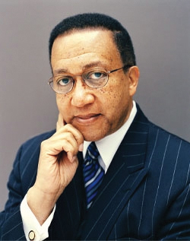

During the Fall of 2014, the NC Museum of History had asked NCABS to come up with the "prompt" for their Junior Historian Elementary Essay Contest, and then to judge the resulting entries. During the month of March, NCABS received those competing Junior Historian Essays, and we began meeting to read and evaluate them. Eleanora Tate, Priscilla Best and Beverly Fields Burnette were judges for the elementary contestants.

On Friday, Apr 24, 2015, the NC Museum of History/Raleigh, NC held their Junior Historian Conference for participating schools from around the State. NCABS also performed three (3) 30-minute Storytelling sessions on the theme of "Memory!" with the students who attended the conference. Afterwards, we presented the Essay winners with their plagues and gifts.

On April 28th, representing NCABS, Beverly Fields Burnette (NCABS president and published poet) was asked to substitute for internationally-known poet Sonia Sanchez (if anyone REALLY could take her place...), since Dr. Sanchez was ill and could not make the flight to Georgia. I stood in for Dr. Sanchez by participating as the guest poet at the Annual 2015 Conference on the Black Experience (COBE) at Paine College:
Theme: Civil Rights and Student Activism in America: Unfinished Business.
Conference dates: April 27-30, 2015
On Sat, May 16, the Rowan Jazz and Blues Festival was held in Salisbury, NC~ NCABS performed two sessions of Storytelling in honor of the late Jackie Torrence from 10:00am - 1:30pm. We had 10 storytellers present.

During the next week of May 21-24th, The African American Storytellers Retreat occurred at The Franklinton Center at Bricks in Whitakers, NC. Many NABS members and several NCABS members attended and "communed" with other Storytellers among Eastern North Carolina's peaceful and pastoral surroundings.
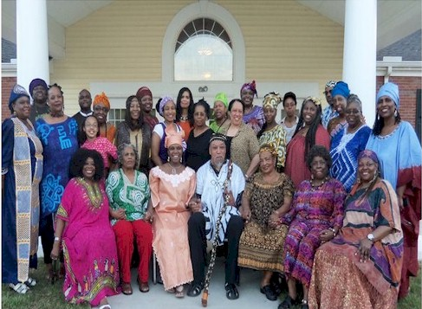

On Wed, May 27, members of NCABS attended a meeting and became aware of a Raleigh Arts Plan Community/ www.africanamericanarts.org, ~and consequently, NCABS was informed/included/invited to be a part of the upcoming Art on Blount Street in downtown Raleigh in July. FAAA's website; www.africanamericanarts.org.

On June 17th- 2015, NCABS had members who attended portions of the Rosenwald Conference Durham, NC, and we learned of new Black histories, new educational efforts and struggles, as well as educational stories from nearly all over the country.

Sat, Jul 11~ Art on Blount Street Day, Raleigh, NC
NCABS was invited to tell Slave narratives and other stories, as they related to people who lived on Blount Street in Raleigh, close to downtown and near Shaw University. Artist Linda Dallas lives and has her Art Studio on Blount Street, and she entertained us to a wonderful luncheon, and invited the public to listen to stories of Black citizens just following the period of enslavement.

On Wed, Jul 29, NCABS had members who attended a local luncheon meeting based on the efforts and plans to digitization of the Freedman's Bureau records. We learned that there is a huge effort to have the records digitized by Juneteenth, 2016..and also before the upcoming opening of the African American Museum at the Smithsonian in Washington DC. Having eventual access to those records will lead to individual, community and family stories and history!

On Thursday, Aug 6, NCABS performed at the National Black Theatre Festival at 10am. The audience was sold out, and they had to move us into another larger venue. Even then, the clamoring audience who still wanted tickets "forced" the NBTF Box Office to "take their cash money" and to let them in.

Since we were scheduled for only one session at the NBTF, NCABS arranged with the Delta Arts Center in Winston Salem to invite church groups and summer day camps to a complimentary
Storytelling session for the community.

On Sat, September 5 and Sunday, September 6th , NCABS Storytellers were again featured at the African American Cultural Festival in downtown Raleigh. We had 10 storytellers who performed during those two days.

At Bowie State Univ. Homecoming on October 6, 2015,
Maryland-transplant-now-NCABS -Storyteller/Artist, Pinkie Strother, was honored at a special Bowie State University Homecoming reception: Art Maker's Exhibit and Reception. Pinkie paired her marvelous artwork: paintings and dioramas with the pre-civil rights small town family stories that her artistry reveals.

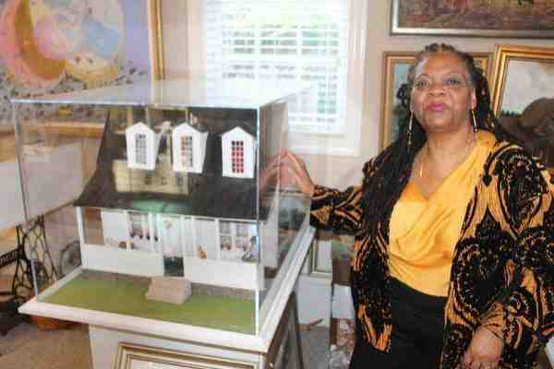
~Pinkie with one of her dioramas~

On Saturday, September 26th ~NCABS was represented at the 77th Anniversary of the Heritage and Culture of John Chavis Memorial Park in Raleigh, NC. ; Storytelling at Chavis Park~ with actor/storyteller Maxwell Paige, an NCABS Storyteller who portrayed 18th century freedman John Chavis at the John Chavis Memorial Park.

On October 15 - 17, NCABS had two representatives at the 36th Annual AAHGS-Afro-American Historical and Genealogical Society, in Richmond, VA. Baba Jamal Koram was also in attendance.

NCABS congratulates our long-time member/storyteller/author Darby West, who celebrated the 10th Anniversary of her book Through the Fire . A book signing was held on Sat., Oct. 17 at Clemmon's Library, Clemmons, NC.

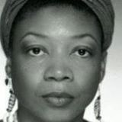Darby West

On October 25th, NCABS sponsored a workshop at NC State University's African American Cultural Center:
Learning MORE about Kwanzaa was lead by Baba Jamal Koram, Affiliate Director for NABS, Inc.

NCABS is associated with other state agencies and groups, who are celebrating Eleanora Tate this Fall.
On Sat, Nov 7, Eleanora Tate is to be celebrated for her book~ Celeste’s Harlem Renaissance . This encompasses "A Walking Tour" in downtown Raleigh...as scenes, streets and landmarks from the book are described and revealed.

And then, continuing on Sat., Nov. 7th at 2:30pm - 4:30pm: Celeste’s Harlem ~ Harking Back to Hargett Street; at the Olivia Raney Local History Library....

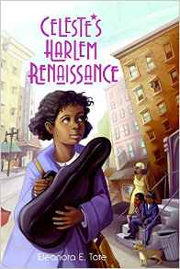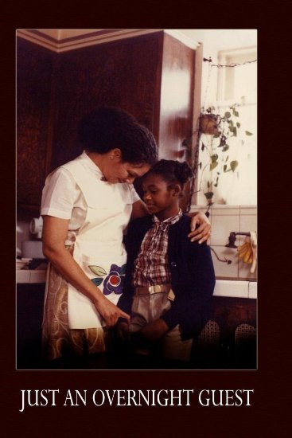

Sat, Nov 21, 2:00pm - 4:00pm: Eleanora Tate at Richard B. Harrison Library/Celebrating Cultures

On Sun, Dec 6, 2:00pm - 4:00pm at the North Carolina Museum of History Movie Screening & Discussion: Just an Overnight Guest~

Sunday, Dec. 6, 2–4 p.m.~ Eleanora E. Tate, Author, and Dr. Nancy Tolson, Assistant Director of African American Studies, University of South Carolina. Just an Overnight Guest was a groundbreaking children’s book in 1980 because it explored the themes of abuse, foster care, adoption, and homelessness. Tate’s compassionate book was also this short film (not rated; run time: 38 min.), starring Richard Roundtree and Rosalind Cash. After the film, Tolson will lead a discussion, Q&A session, and book signing with the author.
From December 26, 2015-January 1st, 2016, Master Storyteller Madafo Lloyd Wilson with poet/storyteller Beverly Fields Burnette~ present A Season's Griot on NPR/PRI ~ in celebration of Kwanzaa.

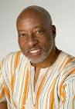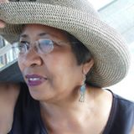
Madafo Lloyd Wilson~ Beverly Fields Burnette

On December 29th, 2015, NCABS presents an hour of Kwanzaa Stories at Cary, NC's Annual Kwanzaa Event.
We are especially happy and proud of Elisha Minter for being awarded the Linda Jenkins Brown Award
and Willa Brigham for being awarded the Zora Neale Hurston Award.

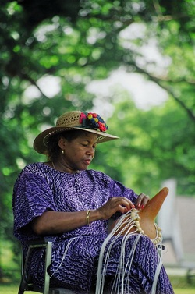
Elisha Minter Willa Brigham

As earlier stated, the NC Association of Black Storytellers, Inc. has had a very full year, and we have happily earned some new NCABS members, and have regained some previous members from the past. We look forward to beginning new endeavors in the coming year, and hope to be able to complete some of our lingering, unfinished plans (such as the formation of a Youth group), ~plans, which have yet eluded us. We also hope to be in contention for the 2018 NABS Festival in Raleigh, NC!

Respectfully submitted by:
Beverly Fields Burnette, President of NCABS
Darby West, Secretary
Willa Brigham, Treasurer

