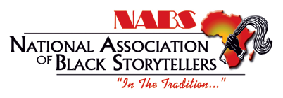
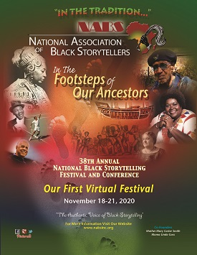
The National Association of Black Storytellers
Goes
VIRTUAL
2020 ANNUAL REPORT
Janice Curtis Greene
16th President, National Association of Black Storytellers

2020 Board
National Association of Black Storytellers
Co-Founder Mama Linda Goss
Executive Director Vanora F. Legaux
President Janice Curtis Greene
President Elect Kwanza Brewer
Sercretary Janice Burnett
Treasurer Dr. Stephanie Davenport
Immediate Past President Sandra Gilliard
Member Rosa Metoyer
Member Kay Merrill
Member Beverly Fields Burnett
Member Dr. David Fakunle

Our Mission
The National Association of Black Storytellers, Inc. (NABS) promotes and perpetuates the art of Black storytelling--an art form which embodies the history, heritage, and culture of African Americans. Black storytellers educate and entertain through the Oral Tradition, which depicts and documents the African-American experience. A nationally organized body with individual, affiliate and organizational memberships, NABS preserves and passes on the folklore, legends, myths, fables and mores of Africans and their descendants and ancestors - "In the Tradition..."

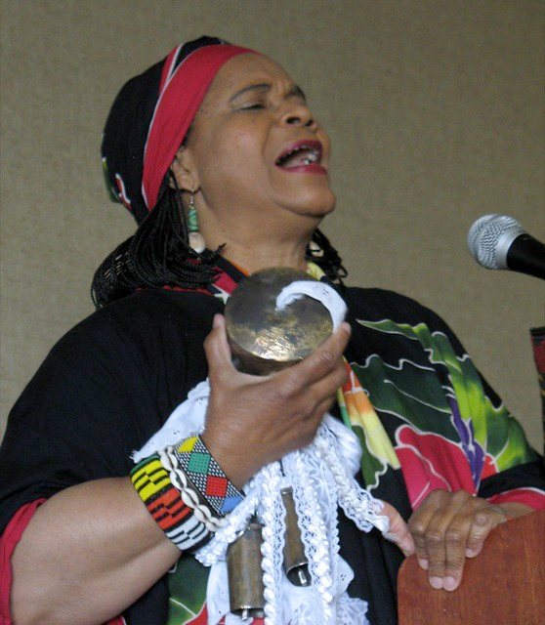
Co-Founder Ancestor, Mother Mary Carter Smith
Co-Founder Mama Linda Goss
NABS is an organization like no other, rich in history and culture, created, as stated in our Mission Statement to promote and perpetuate the art of Blackstorytelling. The talent of our membership is matchless, varying in percussion expertise, vocal skills, fiber artist, dancers, radio & TV hosts and personalities, teachers, visual artists, librarians, professors & scholars. Our stories range from original, traditional, historic, folkloric, personal and historical re-enactments. NABS Tellers entertain, teach, heal, encourage, uplift and bless.

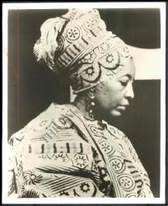
Financial Report
Revenue
2020 Total Contributions $17,855.00
2020 Total Dues $12,150.00
2020 Restricted Funds $18,372.00
2020 Total Income $85,705.00
2020 Total Expenses $67,434.00
2020 Net Income $18,272.00
Operating Fund Balance: $123,475.00
Membership
NABS’s 2020 Membership totals 350 with 58 Regular Members, 171 Elder Members, 19 Youth Members, 65 Silver Life members, 29 Gold life members and 3 organizational members.
NABS Boasts 14 Affiliates in New York, Maryland, Georgia, Minneapolis, Rhode Island, California, Michigan, Ohio, North Carolina, Illinois, Pennsylvania & Utah
1 College Affiliate, Johnson C. Smith College in North Carolina

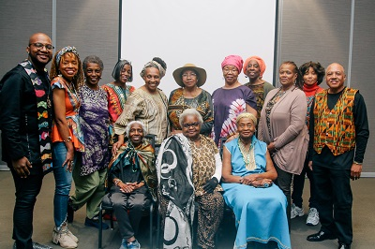
NABS Affiliate Presidents
Year in Retrospect The year 2020 will go down in history with a myriad of emotions.
- Hope - The year started with the anticipation of the centennial celebration of the 19th Constitutional Amendment removing sex as a barrier to the right to vote; although we know that barrier still existed for many Negro Women and the sesqui-centennial of the 15th Amendment granting Negro men the right to vote. We also know that this right continued to be to be withheld and suppressed, even today.
The nation was also poised for the 2020 Census and Presidential Election.
- Shock - In February the COVID-19 Pandemic spread through the United States and the world with a vengeance taking hundreds of thousands of lives, causing shut downs of cities to curb the spread and creating economic hardship due to massive job loss. All of which effected African American communities the hardest.
- Resilience - A record number of hurricanes and tropical storms slammed the Caribbean and Gulf Coast again affecting communities of color the hardest.
- Anger - The nation witnessed the 8 minute 46 second lynching of George Floyd and the onslaught of murders of African American men, women and youth at the hands of those sworn to serve and protect.
- Protest - The nation also witnessed the massive world-wide marches as Black Live Matter transitioned from a protest to a movement.
- Division - White Supremacy rose to become the number one security threat in the nation.
- Victory - The largest number of Americans in the history of this country voted in the 2020 Presidential Election electing Joe Biden to be the 46th President of the United States
- History - Kamala Harris was elected as the first woman, the first woman of African descent and the first woman of South Asian descent to be the Vice President of the United States.
I take this Historical sojourn because this is our story; this is our song. We the NABS Storytellers must continue to tell the truth, our story, our hope, our fears and our victories all the day long.
We are the National Association of Black Storytellers, Inc - and what we do has never been more relevant and imperative as it is today. Mother Mary and Mama Linda knew this and that is why they had the vision to co-found this great organization.

Virtual Village Telling:
To keep NABS members connected during the COVID-19 shutdown President, Janice Curtis Greene instituted Virtual Village Telling.
With the support and assistance of Affiliate Directors TAHIRA and Denise Chapman-Acosta and NABS Executive Director, Vanora Legaux, the team designed, implemented and hosted 3 Virtual Village Telling programs May 13th, June 10th and July 8th this during the Summer. 14 of NABS 15 affiliates were represented. The attendance for all 3 nights totaled approximately 250.
This event was open to NABS Members only to gauge potential attendance and technical needs to host a virtual Festival & Conference in 2020. This event revealed NABS need to purchase Zoom, Event Combo and Survey Monkey accounts to move forward virtually.

2020 Festival and Conference:
Due to the Coronavirus Pandemic the NABS Board deemed it too dangerous for members to travel to Richmond, Virginia for an in-person Festival & Conference. Executive Director, Vanora F. Legaux, and President, Janice Curtis Greene entered into hard-fought negotiations with the Richmond OMNI Hotel and secured release from contractual obligations without incurring penalties.
The quick shift, then had to be made to plan and execute a NABS Virtual Festival. Festival Director, Dylan Pritchett, refused to let the virtual platform alter the integrity of Blackstorytelling for this festival.
The theme “In the Footsteps of the Ancestors” was maintained. The festival included: Awards Ceremonies, Tall Tales Contest, Youth Program, Concerts, Membership Meeting and Workshops, virtually. Pictures of NABS’ family ancestors were also highlighted intermittently.
Attendance:
Total log on count for concerts, workshops and Youth Program is 1413 viewers.
Souvenir Journal:
The 2020 Souvenir Journal, which was again produced by former NABS President, Barbara Eady, was one of the most profitable SJ to date with a profit of approximately $7000.00. The journal not only featured the F&C schedule, pictures and bios of tellers and ads, but also, pictures of family ancestors furnished by NABS members.

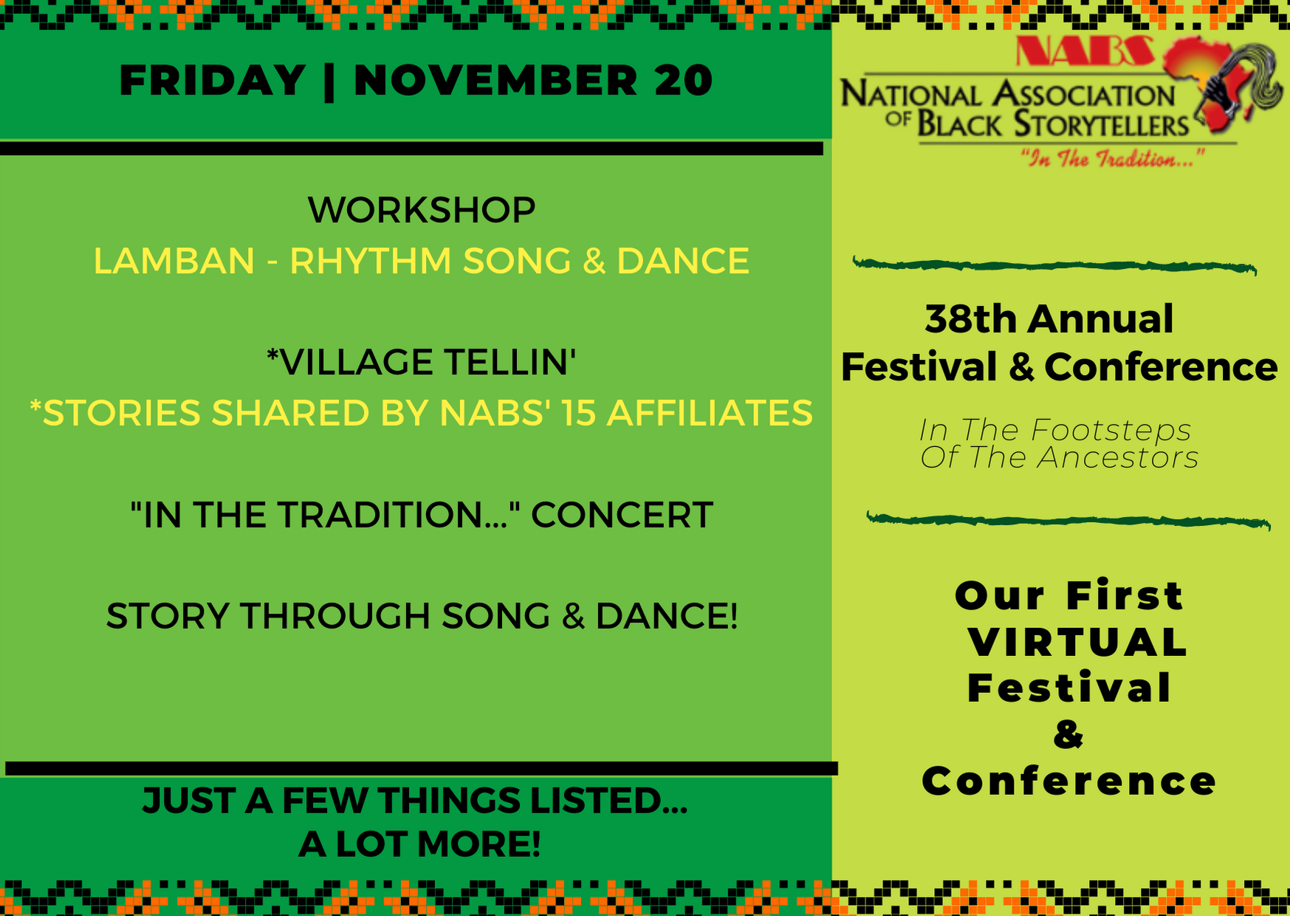

Tech & Advertising
Sheila Arnold
Artist Standing Strong Together, (ASST)
Helping Organizations Leverage Advertising, (HOLA)

Adopt-a-Teller Program (AATP):
The Adopt-a-Teller Directors, Queen Nur and Bunjo Butler successfully continued this free community outreach project by moving to a virtual platform:
2020 Virtual AATP Statistics
Free Live Concert: 1
Placements: 29
Venues: 24
Tellers: 15
Delivery Platforms: Live Stream (24) Recorded (5)
States: 13
Reach via venues: 3935
Social Media Reach: 2246
Total Reached: 6181
The Adopt-a-Teller program sponsored an historical virtual kickoff Virtual Community Concerts on Sunday, November 15, 2020, which peaked at 2000 viewers.
Two Technical Workshops were held for AATP Tellers. Venues were solicited and selected from the 14 NABS Affiliates who paid the venue’s application fees. Technical Administrators were AATP Director, Queen Nur and Event Stream Team, a private vendor.
The NABS AATP was, again, sponsored by the National Endowment for the Arts, Nora Roberts Foundation and National Council for the Traditional Arts. The budget for AATP totaled $19,230.00.
Venues included: 13 Title 1 Schools, 3 Libraries, 1 Recreation Center, 1 Women’s Missionary, 2 Universities, 1 Theater, 1 Church and 1 Home School Group.
States: FL, NC, MD, DE, OH, TX, GA, UT, NY, NJ, MO, VA, IL
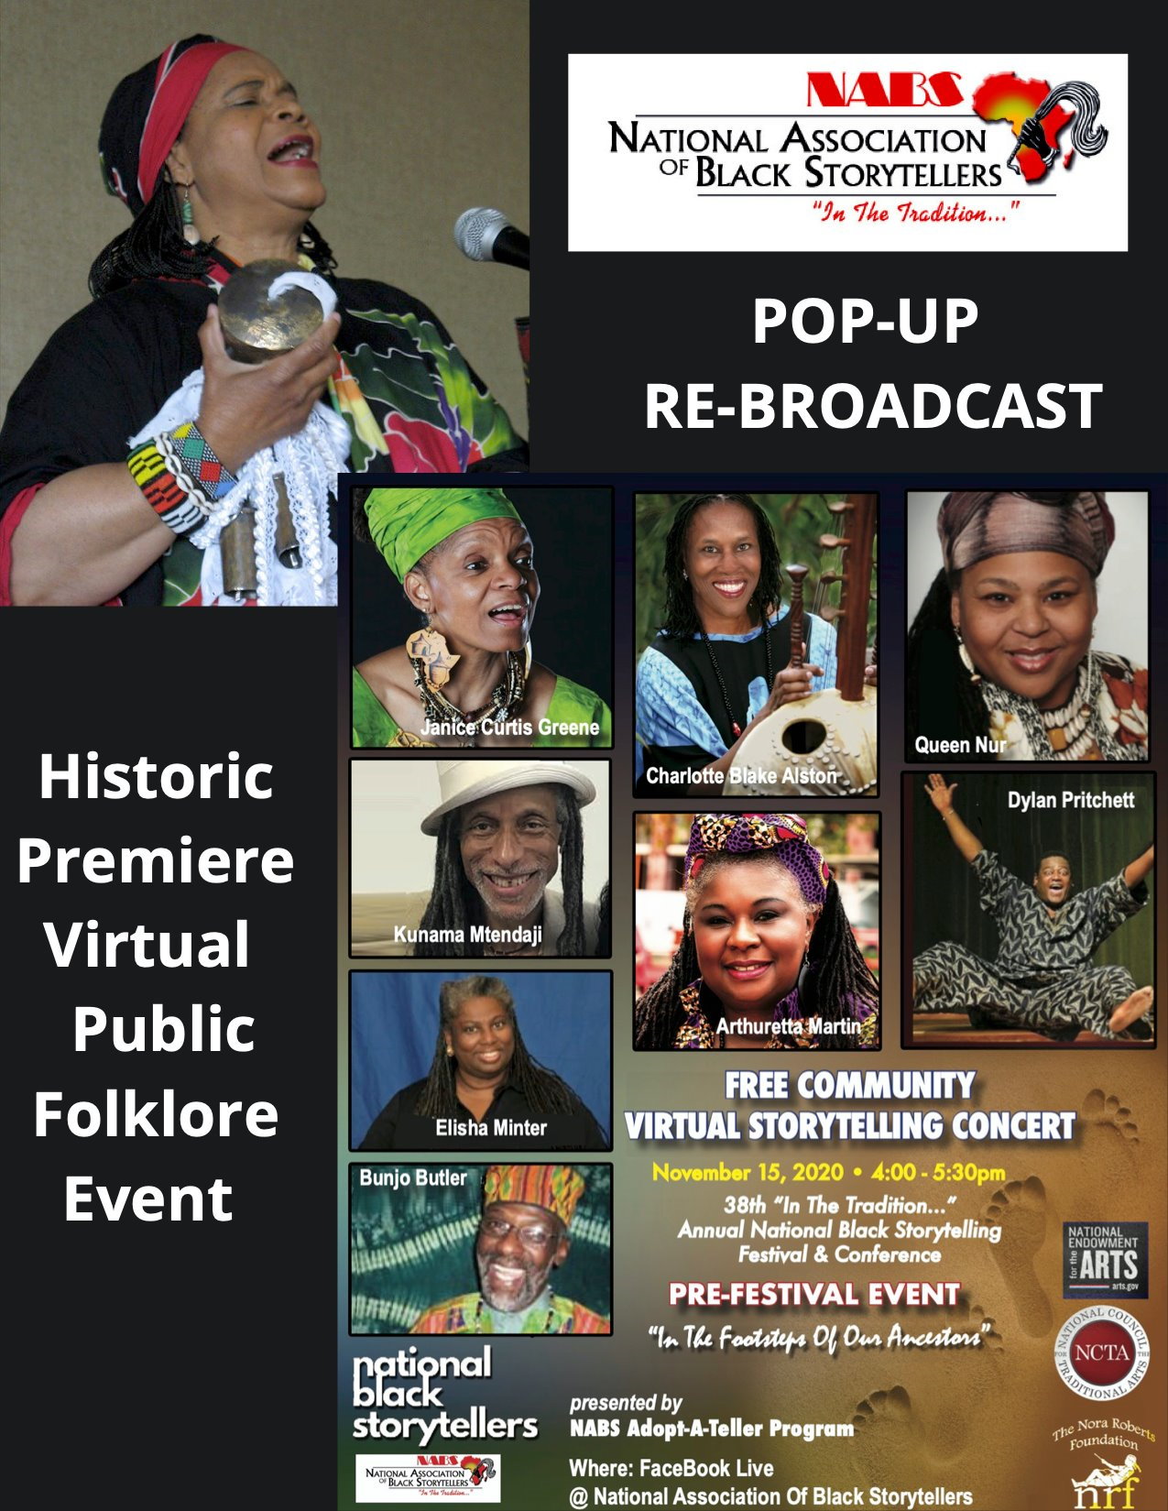

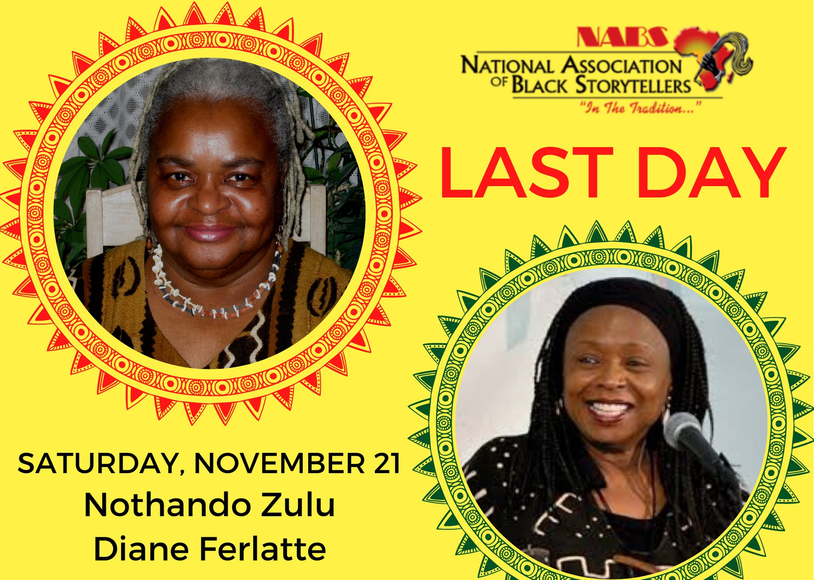

The NABS Board voted to cancel the contract with the Plaza Hotel in Salt Lake City, Utah for the 2021 39th NABS Festival & Conference before penalties could be charged.
For the continued safety of NABS’ members, the Board voted that the 2021 NABS Festival & Conference would be virtual. Decisions about the 2022 Festival & Conference will be made after assessing the spread of COVID 19.

During 2020 the National Association of Black Storytellers welcomed new NABS Board Member, Dr. Stephanie Davenport, who was sworn in at the November Festival & Conference and who will serve as NABS Treasurer.
The Cowtail Switch was virtually passed to President-Elect Kwanza Brewer, who will begin her term as NABS’ 17th President, January 1, 2021

Mama Linda Induction:
I am proud to report that effective December 20, 2020 funds have been secured, donated or pledged in the amount of $25, 000.00 to complete payment for and begin the process of having Co-Founder, Linda Goss, enshrined in the National Great Blacks in Wax Museum in Baltimore, Maryland. Her wax figure will be featured along-side that of Mother Mary Carter Smith. The unveiling is scheduled to take place during the NABS 2022, 40th Annual Festival & Conference in Baltimore, Maryland.

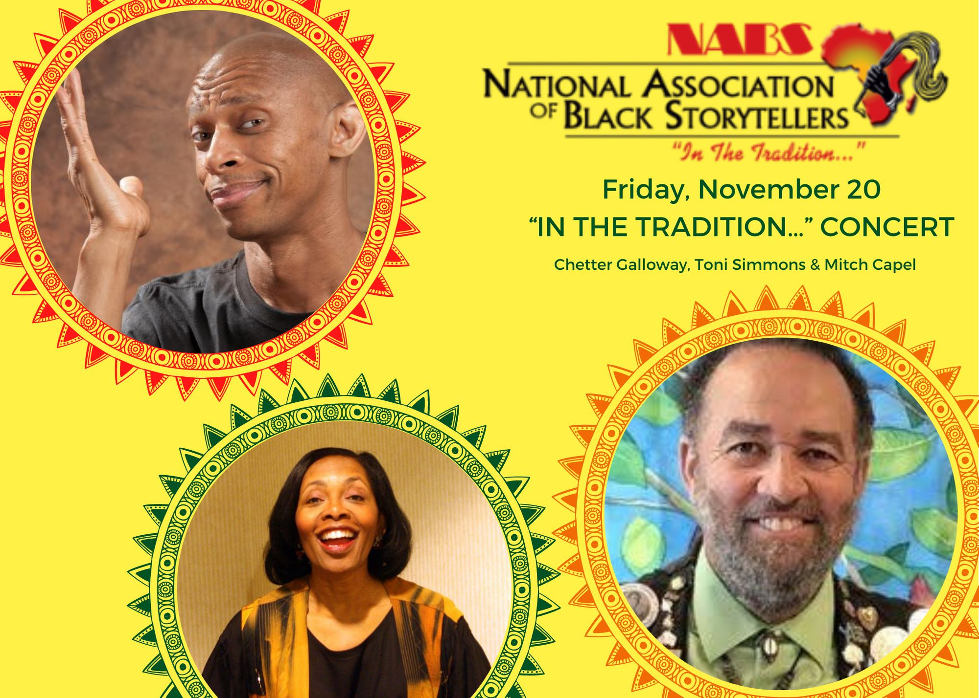
NABS AFFILIATES
NABS Affiliates continue to provide rich history across the Globe
African Folk Heritage Circle
Black Storytellers of San Diego
KUUMBA Storytellers of Georgia
Cleveland Assn. of Black Storytellers
North Carolina Assn. of Black Storytellers
Rhode Island Black Storytellers
Black Storytellers Alliance
Keepers of the Culture of Pennsylvania
Detroit Assn. Black Storytellers
The Griots’ Circle of Maryland
Tradition Keepers: Black Storytellers of Western New York
Blackstorytelling League of Rochester, NY
ASE: The Chicago Association of Black Storytellers
Nubian Storytellers of Utah Leadership

The NABS Affiliates sponsored Virtual Storytelling Concerts and Classes to safely keep us connected. Kuumba Anniversary concerts and Papa Tales had us laughing and crying. Vusi and Nothando Zulu in Minnesota held Virtual Storytelling Classes, then invited the NABS community to enjoy the graduation. Even a Pandemic could not keep the Griots’ Circle from holding their annual Love Stories Concert, virtually. Let us not forget the monthly DABS Virtual Friday Programs. ASE of Chicago hosted a virtual Historical Program and Keepers of the Culture would not allow their Youth Component to suffer during lock-down and continued their Watoto Concert.
Every NABS Affiliate worked diligently to prove that footsteps of the Ancestors could not be erased and the voices of the Ancestors could not be silenced.

To the NABS Board,
I am profoundly grateful for all the prayers and support you have given me during my Presidency. The administration of NABS’ affairs was truly a collaborative effort.

To All NABS Members,
I pray that I have served you and this great organization with integrity.

To the Executive Director, Vanora Franklin Legaux
Thank you for your leadership and commitment to NABS.

To the Festival Director, Dylan Pritchett
You were able to orchestrate NABS’ 38th Festival and Conference virtually without losing the joy and energy NABS members are accustomed to feeling in-person.

To the President-Elect, Kwanzaa Brewer
Know that I am still on the board to help you through the most difficult job you will ever love.

To the Co-Founder, Mama Linda Goss,
God Bless you! Thank you for trusting me with the care of this sacred organization.

Thank you one and all. I leave my office of President of the National Association of Black Storytellers with a Grateful and Loving Heart.
Respectfully Submitted,
Janice Curtis Greene, 16th President

