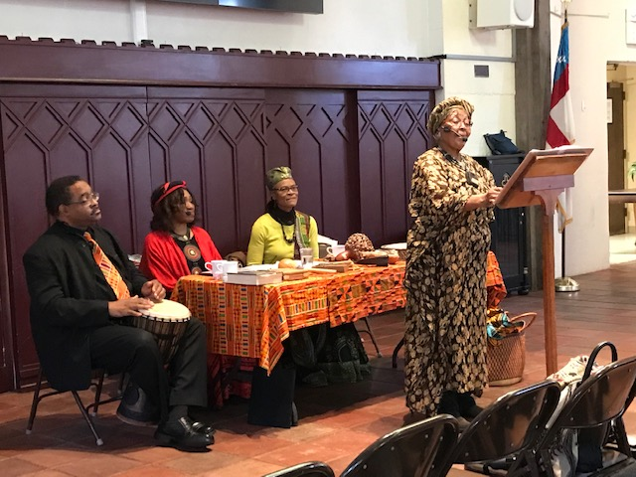
BSSD preforms “Blacks in the Bible”-Sunday School Forum- St Paul Episcopal Cathedral
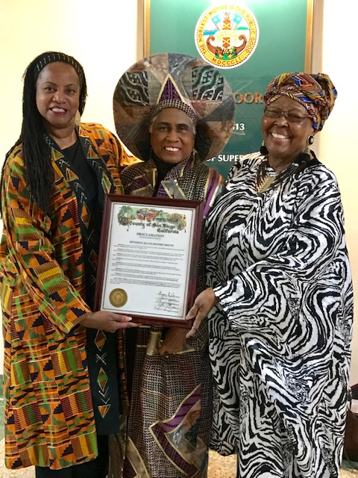
BSSD presented Proclamation from City of San Diego-- -Three Original Charter Members- Dr. T. Ford, Ms. Linda Brown, and Elder “Ms. Flo” Florence Edmunds

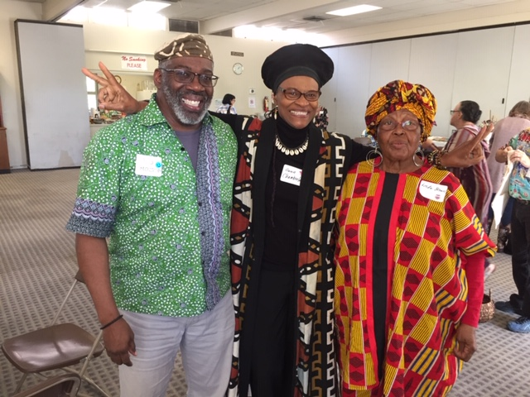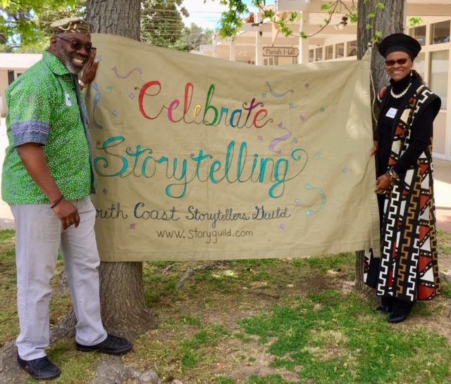
BSSD participates in SoCal’s Story Swap-Tustin, CA
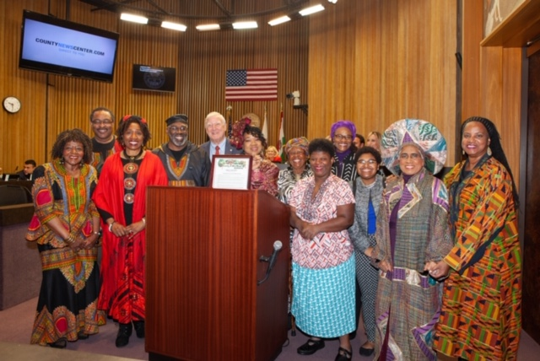
BSSD receives Proclamation from City of San Diego in recognition of Black History Month
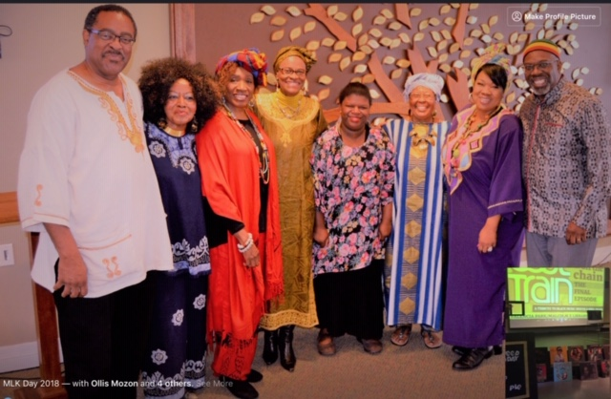
BSSD Celebrates Black History at Point Loma Community Presbyterian Church
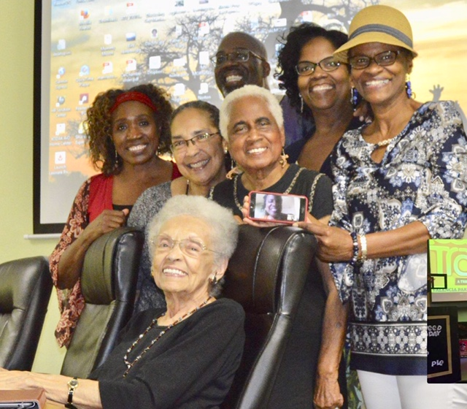
BSSD Retreats in Oceanside, CA. Celebrating our Elders and preparing for another year!

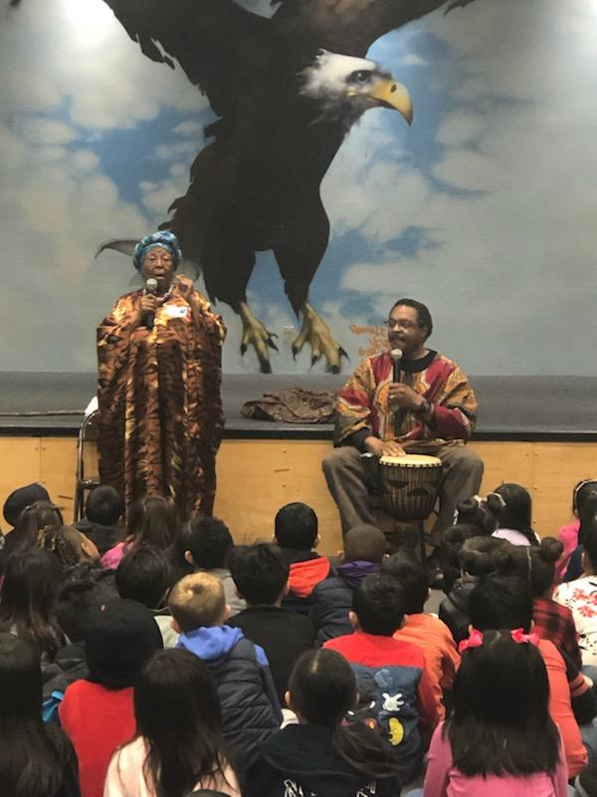
Members Linda Brown and Wesley Thomas entertain students at Nye Elementary
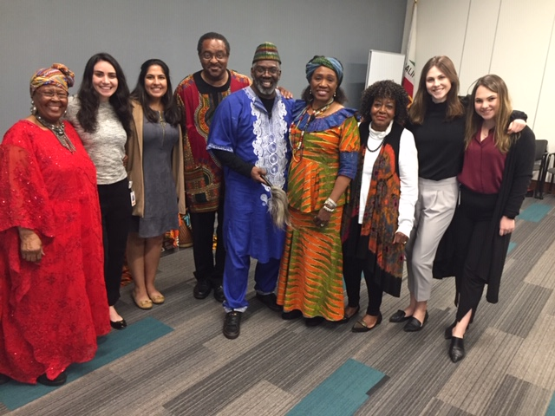
BSSD celebrates Black History Month with stories of Black History and African Culture at
Sempra Energy Employee Luncheon

