National Association of Black Storytellers, Inc (NABS) 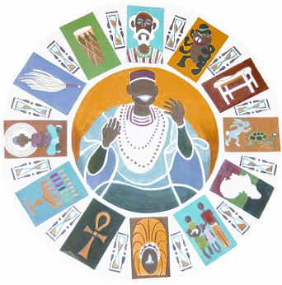 Keepers of the Culture, Inc. (KOTC) Affiliate Update November 2022 – November 2023

Overview
KOTC continues rebounding from COVID Pandemic and Post Pandemic effects.
We are only now slowly restarting - overcoming such obstacles as decreased
storytelling opportunities, programs and reduced KOTC membership numbers. Our programs
have begun to target a youthful demographic that we very much need in the development
and work of Black Storytelling. Nevertheless, KOTC manages to persevere.

KOTC Elections
In Feb 2023, KOTC held membership officer elections. The votes filled the following
positions:
Recording Secretary
Carla Wiley
Treasurer
Nashid Ali
Spiritual Caretakers
Ron Carter
Nzinga Asele El

As there were no candidates for KOTC President and Vice
President, KOTC elders formed a KOTC Leadership Council (KLC) to
administrate and lead the organization.

KOTC Organizational Administration & Leadership
KOTC Leadership Council (KLC) consist of an uneven number
of financial members who make decisions for the governance of the
organization. KLC takes on roles and responsibilities of the President
and Vice-President guiding the helm of day-to-day, short term and long-term
duties that fulfill KOTC’s core purpose. KLC is an Ad-Hoc Committee.
When the KOTC general membership duly elects a President, that President then
may discharge the KLC from their goals. The KLC handles (but are not limited to) the
following tasks:
- Developing programs
- Developing membership
- Developing workshops
- Developing/mentoring KOTC leadership
- Being representative of KOTC in the public sphere
- Facilitating meetings
Membership Recruitment
Currently a small active general membership forms KOTC’s nucleus.
KOTC recruiting potential storytellers while attracting seasoned alumni is a priority.
Saturday June 3, 2023, KOTC initiated this effort by holding the first in a series of
“Black Storytelling Meet and Greets -Sharing Our Stories” events. Other planned
“Black Storytelling Meet and Greets” are schedulded to take place in a variety of
Philadelphia neighborhood locations
October 2023 KLC convened a general membership meeting.
At the general membership meeting attendees discussed ideas for rebuilding
the organization along with a NABS update of which KOTC applauds the
appointment of Dr. Carolise Frink Reed, a KOTC founder, to the newly
created position of NABS Scholar in Residence and Past-President of KOTC and NABS, Queen Nur to her induction to the Brother Blue Circle of Elders and a recipient of the Linda Brown and Charlie Brown Service Award.
Partnerships & Programs
Even though COVID closed or drastically altered storytelling opportunities via partnerships,
programs, and schools, KOTC weathered this storm by performing via zoom in
such venues our annual participation in Philadelphia Free Library’s Sunday on Stage
(post pandemic changes, budget cuts and unfamiliar staff turnover now threatens this
twenty plus year partnership, in addition to others in these changing times).

With COVID restrictions widely lifting, KOTC Storytellers took part as Teaching
Artists at Philadelphia’s Folk Arts and Treasures Charter School as well as the
historic abolitionist Stenton House.

Respectfully Submitted
KOTC Leadership Council (KLC)
October 31, 2023

